INSTITUTE OF AERONAUTICAL ENGINEERING
(Autonomous)
Dundigal, Hyderabad - 500 043



Lecture Notes:

NATURAL LANGUAGE PROCESSING (AITD11)

Drafted by :
B. Lakshmi Prasanna Assistant Professor

CSE/ IT/ DS
Institute of Aeronautical Engineering DEC 2026

Contents
- NATURAL LANGUAGE PROCESSING

  - Introduction to Natural Language Processing (NLP) 1
  - Applications or Use cases of NLP 4
  - Components of NLP 10
  - Approaches for Text Representation 11
  - Steps in NLP, Finding the Structure of Words 12
  - Importance of Morphological Analysis 13
  - Tokenization Explained 14
  - POS(Parts-Of-Speech) Tagging in NLP 17
  - Syntactic Analysis (Parsing 21
- REGULAR EXPRESSIONS, TEXT NORMALIZATION
  - Regular Expressions, Text Normalization 35
  - Patterns 37
  - Words 38
  - Approaches for Text Representation 39
  - Text normalization 41
  - Minimum edit distance 42
  - Regular Language and FSAs 45
  - Raw Text Extraction and Tokenization 46
  - Extracting Terms from Tokens 49
- N-GRAM LANGUAGE MODELS
  - N-grams 53
  - Evaluating language model 54
  - Generalization and zeros 55
  - Kneser-Ney (KN) smoothing in NLP 56
  - Huge language models and stupid back off. 57
  - Perplexity’s relation to Entropy 58
  - Inflection 59
  - Derivational Morphology 60
  - Finite-State Morphological Parsing 62
- WORD SENSE DISAMBIGUATION
  - Methodological Preliminaries 66
  - Supervised Disambiguation: Bayesian classification 67
  - An Information-Theoretic Approach 67
  - Disambiguation based on sense 68
  - Thesarus-based Disambiguation 69
  - Disambiguation based on translations in a second-language corpus. 70
- MARKOV MODEL AND POS TAGGING
  - Hidden Markov Model in Machine learning 70
  - Components of a Hidden Markov Model (HMM) 71
  - Three Fundamental Problems in Hidden Markov Models (HMMs) 71
  - Markov Property 74
  - Variants 75
  - The Information Sources in Tagging 78
  - The Information Sources in Tagging: Markov model taggers 79
  - The Viterbi Algorithm 80
  - Applications of Viterbi in HMM 80
  - Applying HMMs to POS tagging 81
  - Components associated with Hidden Markov Models 86
  - Components of a Hidden Markov Model (HMM) 92

MODULE 1: NATURAL LANGUAGE PROCESSING

Introduction to Natural Language Processing (NLP)
Natural Language Processing (NLP) enables computers to understand and interpret human language. While computers excel at processing structured data, such as spreadsheets or databases, natural language in its unstructured form (text, speech, etc.) presents a unique challenge. NLP bridges this gap by allowing machines to process and understand human languages, making it an essential tool in modern AI systems.
Let's learn more about Natural Language Processing in this article.

Need for Natural Language Processing
The growing amount of unstructured natural language data in the world makes it increasingly important for machines to comprehend and analyze it effectively. By training NLP models, we can equip computers to process language data in a variety of forms, from written text to voice input. With centuries of human-written literature and massive data available, it’s vital to teach computers to interpret that wealth of information. However, this task comes with significant challenges, such as resolving ambiguities in meaning, Named-Entity Recognition (NER), and coreference resolution.
While NLP systems are improving, they still face difficulties in understanding the exact meaning of sentences.
For example, consider the phrase: "The boy radiated fire-like vibes." Does it refer to a motivating personality or imply something literal? Such ambiguities make text analysis complex for computers.
To solve these challenges, NLP breaks down language understanding into smaller, manageable components. This approach, known as the NLP pipeline, involves several stages that collectively enable machines to interpret human language effectivel

Key Steps in Natural Language Processing (NLP) Pipeline
- Sentence Segmentation
Sentence segmentation is the first step in NLP, which involves breaking text into individual sentences. This helps the computer understand the structure of the text.
Example Input: San Pedro is a town on the southern part of Ambergris Caye in Belize. According to estimates, it has a population of 16,444.

Output:

  - Sentence 1: San Pedro is a town on the southern part of Ambergris Caye in Belize.
  - Sentence 2: According to estimates, it has a population of 16,444.

Word Tokenization
Word tokenization divides sentences into smaller components called tokens (words or punctuation). These tokens are crucial for understanding how a sentence is structured.
Example Input: San Pedro is a town in Belize.
Output: Tokens: ['San', 'Pedro', 'is', 'a', 'town', 'in', 'Belize']

Predicting Parts of Speech (POS)
POS tagging involves identifying the function of each word in a sentence, such as whether it's a noun, verb, or adjective. This helps determine the role each word plays in the context of the sentence.
Example Input: San Pedro is a town.
Output: 'San Pedro' - Noun, 'is' - Verb, 'a' - Article, 'town' - Noun

Lemmatization
Lemmatization converts words to their root forms. For example, "Buffalo" and "Buffaloes" are both lemmatized to "Buffalo," ensuring that variations of the same word are treated identically.
Example Input: There are Buffaloes grazing in the field.
Output: Buffalo (root word)

Stop Word Removal
Stop words (e.g., "a," "the," "and") are common words that provide minimal meaning. Removing them helps reduce noise and improve the efficiency of NLP models.

Dependency Parsing
Dependency parsing identifies relationships between words, creating a syntactic tree. This helps understand the grammatical structure of a sentence and the roles of each word.
Example Input: San Pedro is an island in Belize.
Output: Parse Tree: ‘San Pedro’ (subject) → ‘is’ (verb) → ‘island’ (object) Noun phrases group related words to represent a specific concept. In the sentence "The second-largest town in the Belize District," we can extract the noun phrase "second-largest town."

Named Entity Recognition (NER)
NER identifies and categorizes entities such as people, places, or dates in text.

Example Input: San Pedro is a town on the southern part of the island of Ambergris Caye in the Belize District of the nation of Belize, in Central America.

Output:
  - San Pedro: Geographic Entity
  - Ambergris Caye: Geographic Entity
  - Belize: Geographic Entity
  - Central America: Geographic Entity

Coreference Resolution
Coreference resolution identifies when two or more expressions in a text refer to the same entity. For example, the word "it" might refer to a specific person or thing earlier in the sentence.
Example Input: San Pedro is a town on the southern part of the island of Ambergris Caye. According to 2015 mid-year estimates, the town has a population of about 16,444. It is the second-largest town in the Belize District.
Output: "It" refers to "San Pedro." Techniques Used in NLP
NLP techniques can be broadly categorized into two approaches:
- Rule-based Methods: These involve manually created rules and heuristics to process language data. For example, defining patterns in language to extract meaning.
- Machine Learning (ML) and Deep Learning (DL): These involve using algorithms to automatically learn from data and improve over time. ML models such as decision trees, support vector machines, and deep learning models like recurrent neural networks (RNNs) and transformers are commonly used in modern NLP.
One of the most prominent breakthroughs in NLP in recent years has been the use of transformers, a type of deep learning architecture that powers models like BERT and GPT. These models excel at tasks like language understanding and generation, enabling applications like chatbots and automated content creation. Applications of NLP
- Speech Recognition: Converting spoken language into text, which powers voice assistants like Siri and Alexa.
- Language Translation: Automatically translating text from one

- Chatbots and Virtual Assistants: Understanding and responding to user queries in natural language (e.g., customer support).
- Text Summarization: Condensing long documents into shorter summaries without losing important information.
- Sentiment Analysis: Understanding opinions expressed in text, which is useful in social media monitoring, product reviews, and customer feedback analysis.
- Information Retrieval: Enhancing search engines by interpreting and matching search queries with relevant documents.

Applications or Use cases of NLP
Natural Language Processing (NLP) is a branch of Artificial Intelligence (AI) that helps machines to understand and process human languages either in text or audio form. It is used across a variety of applications from speech recognition to language translation and text summarization.

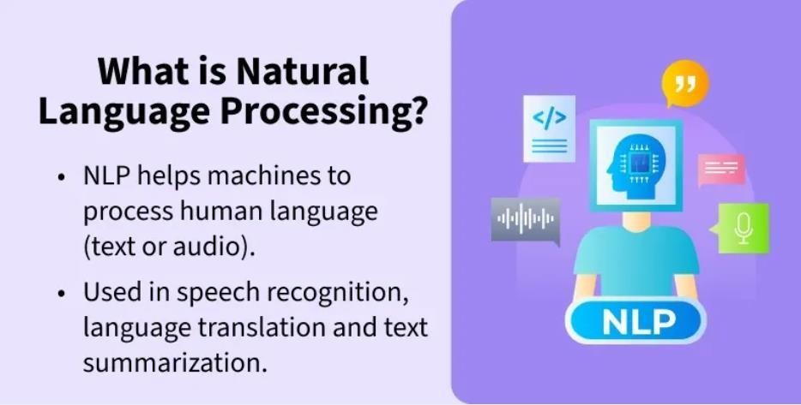

Natural Language Processing can be categorized into two components:
- Natural Language Understanding: It involves interpreting the meaning of the text.
- Natural Language Generation: It involves generating human-like text based on processed data.

  - Natural Language Understanding
  - Natural Language Generation

Phases of Natural Language Processing
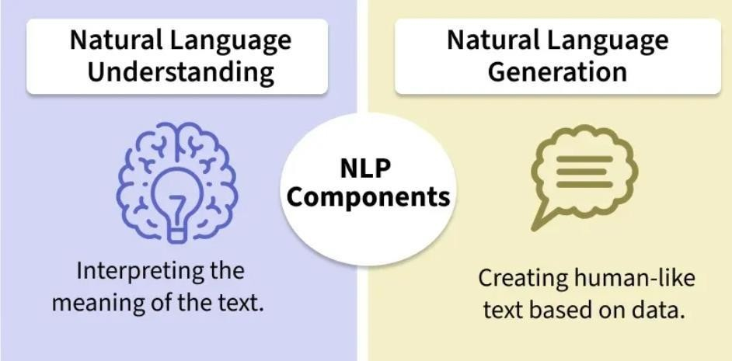
It involves a series of phases that work together to process and interpret language with each phase contributing to understanding its structure and meaning.

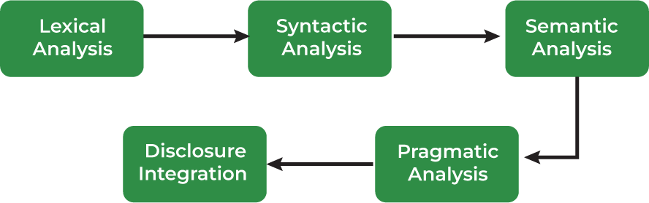

Phases of NLP
For more details you can refer to: Phases of NLP

Libraries for NLP
Some of natural language processing libraries include:
  - NLTK (Natural Language Toolkit)

  - TextBlob
  - Transformers (by Hugging Face)
  - Gensim
  - NLP Libraries in Python.

Normalizing Textual Data in NLP
Text Normalization transforms text into a consistent format improves the quality and makes it easier to process in NLP tasks.
Key steps in text normalization includes:
- Regular Expressions (RE) are sequences of characters that define search patterns.
  - Text Normalization
  - Regular Expressions (RE)
  - How to write Regular Expressions?
  - Properties of Regular Expressions
  - Email Extraction using RE
- Tokenization is a process of splitting text into smaller units called tokens.
  - Tokenization
  - Word Tokenization
  - Rule-based Tokenization
  - Subword Tokenization
  - Dictionary-Based Tokenization
  - Whitespace Tokenization
  - WordPiece Tokenization
- Lemmatization reduces words to their base or root form.
  - Lemmatization
- Stemming reduces works to their root by removing suffixes. Types of stemmers include:
  - Stemming
  - Porter Stemmer
  - Lancaster Stemmer
  - Snowball Stemmer
  - Rule-based Stemming
- Stopword removal is a process to remove common words from the document.

  - Parts of Speech (POS) Tagging

Text Representation and Embedding Techniques in NLP
Lets see how these techniques works in NLP.

Text representation Techniques
It converts textual data into numerical vectors that are processed by the following methods:
  - One-Hot Encoding
  - Bag of Words (BOW)
  - Term Frequency-Inverse Document Frequency (TF-IDF)
  - N-Gram Language Modeling with NLTK
  - Latent Semantic Analysis (LSA)
  - Latent Dirichlet Allocation (LDA)

Text Embedding Techniques
It refers to methods that create dense vector representations of text, capturing semantic meaning including advanced approaches like:

Word Embedding
  - Word2Vec (SkipGram, Continuous Bag of Words - CBOW)
  - GloVe (Global Vectors for Word Representation)
  - fastText

Pre-Trained Embedding
  - ELMo (Embeddings from Language Models)
  - BERT (Bidirectional Encoder Representations from Transformers)

Document Embedding
  - Doc2Vec

Advanced Embeddings
  - RoBERTa
  - DistilBERT

Deep Learning Techniques for NLP
Deep learning has revolutionized Natural Language Processing by helping models to automatically learn complex patterns from raw text.
Key deep learning techniques in NLP include:
  - Deep learning
  - Artificial Neural Networks (ANNs)
  - Recurrent Neural Networks (RNNs)

  - Seq2Seq Models
  - Transformer Models

Pre-Trained Language Models
Pre-trained models can be fine-tuned for specific tasks:
  - Pre-trained models
  - GPT (Generative Pre-trained Transformer)
  - Transformers XL
  - T5 (Text-to-Text Transfer Transformer)
  - Transfer Learning with Fine-tuning

Natural Language Processing Tasks
Core NLP tasks that help machines understand, interpret and generate human language.

Text Classification
  - Dataset for Text Classification
  - Text Classification using Naive Bayes
  - Text Classification using Logistic Regression
  - Text Classification using RNNs
  - Text Classification using CNNs

Information Extraction
  - Named Entity Recognition (NER) using SpaCy
  - Named Entity Recognition (NER) using NLTK
  - Relationship Extraction

Sentiment Analysis
  - What is Sentiment Analysis?
  - Sentiment Analysis using VADER
  - Sentiment Analysis using Recurrent Neural Networks (RNN)

Machine Translation
  - Statistical Machine Translation of Language
  - Machine Translation with Transformer

Text Summarization
  - What is Text Summarization?
  - Text Summarizations using Hugging Face Model
  - Text Summarization using Sumy

Text Generation
  - Text Generation using Fnet
  - Text Generation using Recurrent Long Short Term Memory Network
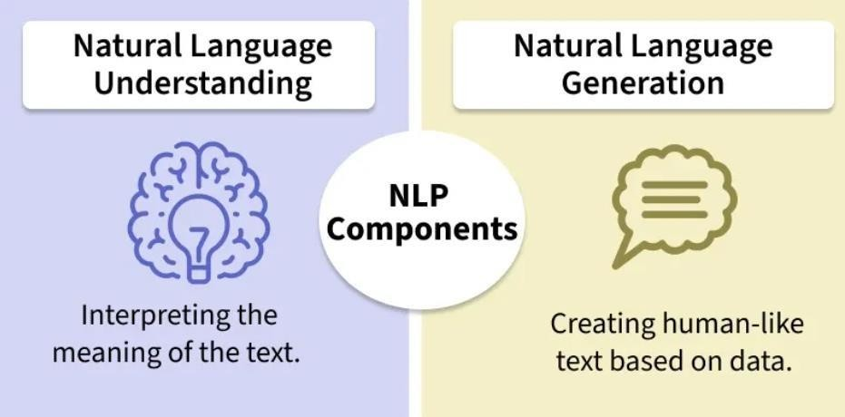
  - Text2Text Generations using HuggingFace Model

Natural Language Processing Chatbots
NLP chatbots are computer programs designed to interact with users in natural language helps in seamless communication between humans and machines. By using NLP techniques, these chatbots understand, interpret and generate human language.
  - What is Natural Language Processing (NLP) Chatbots?

Applications of NLP
- Voice Assistants: Alexa, Siri and Google Assistant use NLP for voice recognition and interaction.
- Grammar and Text Analysis: Tools like Grammarly, Microsoft Word and Google Docs apply NLP for grammar checking.
- Information Extraction: Search engines like Google and DuckDuckGo use NLP to extract relevant information.
- Chatbots: Website bots and customer support chatbots leverage NLP for automated conversations.
For more details you can refer to: Applications of NLP

Importance of NLP
Natural Language Processing (NLP) plays an important role in transforming how we interact with technology and understand data. Below are reasons why

- Information Extraction: Extracts useful data from unstructured content.
- Sentiment Analysis: Analyzes customer opinions for businesses.
- Automation: Streamlines tasks like customer service and document processing.
- Language Translation: Breaks down language barriers with tools like Google Translate.
- Healthcare: Assists in analysing medical records and research.

Components of NLP
There are the following two components of NLP –

Natural Language Understanding (NLU)
    - Natural Language Understanding (NLU) helps the machine to understand and analyse human language by extracting the metadata from content such as concepts, entities, keywords, emotion, relations, and semantic roles.
NLU mainly used in Business applications to understand the customer’s problem in both spoken and written language. NLU involves the following tasks –
      - It is used to map the given input into useful representation.
      - It is used to analyze different aspects of the language.

Natural Language Generation (NLG)
Natural Language Generation (NLG) acts as a translator that converts the computerized data into natural language representation. It mainly involves Text planning, Sentence planning, and Text Realization. Difference between NLU and NLG

NLU | NLG
NLU is the  process of  reading and interpreting language. | NLG is the process of writing or generating language.
It produces non-linguistic outputs from natural language inputs. | It produces constructing natural language outputs from non-linguistic inputs.
- Phases of NLP

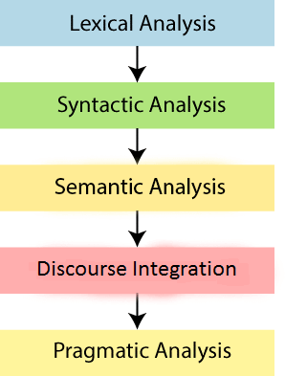
1.4 There are the following five phases of NLP:

- Lexical Analysis and Morphological

The first phase of NLP is the Lexical Analysis. This phase scans the source code as a stream of characters and converts it into meaningful lexemes. It divides the whole text into paragraphs, sentences, and words.

Syntactic Analysis (Parsing)
Syntactic Analysis is used to check grammar, word arrangements, and shows the relationship among the words.
Example: Agra goes to the Poonam
In the real world, Agra goes to the Poonam, does not make any sense, so this sentence is rejected by the Syntactic analyzer.

Semantic Analysis
Semantic analysis is concerned with the meaning representation. It mainly focuses on the literal meaning of words, phrases, and sentences.

Discourse Integration
Discourse Integration depends upon the sentences that proceeds it and also invokes the meaning of the sentences that follow it.

Pragmatic Analysis
Pragmatic is the fifth and last phase of NLP. It helps you to discover the intended effect by applying a set of rules that characterize cooperative dialogues.
For Example: —Open the door‖ is interpreted as a request instead
of an order.

Steps in NLP, Finding the Structure of Words: Words and Their Components,
- Lexical and Morphological Analysis Lexical Analysis
It focuses on identifying and processing words (or lexemes) in a text. It breaks down the input text into individual tokens that are meaningful units of language such as words or phrases.

Key tasks in Lexical analysis:
  - Tokenization: Process of dividing a text into smaller chunks called tokens. For example the sentence "I love programming" would be tokenized into ["I", "love", "programming"].
  - Part-of-Speech Tagging: Assigning parts of speech such as noun, verb, adjective to each token in the sentence. This helps us to understand grammatical roles of words in the context.
Example: Consider the sentence: "I am reading a book."
    - Tokenization: Sentence is broken down into individual tokens or words: ["I", "am", "reading", "a", "book"]
    - Part-of-Speech Tagging: Each token is assigned a part of speech: ["I"
→ Pronoun (PRP), "am" → Verb (VBP), "reading" → Verb (VBG), "a"
→ Article (DT), "book" → Noun (NN)]

Importance of Lexical Analysis
    - Word Identification: It breaks text into tokens which helps the system to understand individual words for further processing.
    - Text Simplification: It simplifies text through tokenization and stemming which improves accuracy in NLP tasks.

Morphological Analysis
It deals with morphemes which are the smallest units of meaning in a word. It is important for understanding structure of words and their parts by identifying free morphemes (independent words like "cat") and bound morphemes (like prefixes or suffixes e.g. "un-" or "-ing").

Key tasks in morphological analysis:
- Stemming: Reducing words to their root form like "running" to "run".
- Lemmatization: Converting words to their base or dictionary form considering the context like "better" becomes "good".

Importance of Morphological Analysis
    - Understanding Word Structure: It helps in breaking the composition of complex words.
    - Improving Accuracy: It enhances accuracy of tasks such as part-of-speech tagging, syntactic parsing and machine translation.
By identifying and analyzing morphemes system can identify text correctly at the most basic level which helps in more advanced NLP applications.

What is Tokenization?
Tokenization is a fundamental process in Natural Language Processing (NLP) that involves breaking down a stream of text into smaller units called tokens. These tokens can range from individual characters to full words or phrases, Based on how detailed it needs to be. By converting text into these manageable chunks, machines can more effectively analyze and understand human language.

Tokenization Explained
Tokenization can be likened to teaching someone a new language by starting with the alphabet, then moving on to syllables, and finally to complete words and sentences. This process allows for the dissection of text into parts that are easier for machines to process. For example, consider the sentence, "Chatbots are helpful." When tokenized by words, it becomes:
["Chatbots", "are", "helpful"]
If tokenized by characters, it becomes:
["C", "h", "a", "t", "b", "o", "t", "s", " ", "a", "r", "e", " ", "h", "e", "l", "p", "f", "u", "l"]
Each approach has its own advantages depending on the context and the specific NLP task at hand.

Types of Tokenization
Tokenization can be classified into several types based on how the text is segmented. Here are some types of tokenization:

    - Word Tokenization: This is the most common method where text is divided into individual words. It works well for languages with clear word boundaries, like English.
    - Character Tokenization: In this method, text is split into individual characters. This is particularly useful for languages without clear word boundaries or for tasks that require a detailed analysis, such as spelling correction.

    - Sub-word Tokenization: Sub-word tokenization strikes a balance between word and character tokenization by breaking down text into units that are larger than a single character but smaller than a full word.
    - Sentence Tokenization: Sentence tokenization is also a common technique used to make a division of paragraphs or large set of sentences into separated sentences as tokens.
    - N-gram Tokenization: N-gram tokenization splits words into fixed-sized chunks (size = n) of data.

Tokenization Use Cases
Tokenization is critical in numerous applications, including:
      - Information Retrieval: Tokenization is essential for indexing and searching in systems that store and retrieve information efficiently based on words or phrases.
      - Search Engines: Use tokenization to process and understand user queries. By breaking down a query into tokens, enhance efficiency match and return precise search results.
      - Machine Translation: Tools like Google Translate rely on tokenization to convert sentences from one language into another. Segment and Reconstruct to preserve meaning.
      - Speech Recognition: Voice assistants such as Siri and Alexa use tokenization to process spoken language. Command is first converted into text and then tokenized, enabling the system to understand and execute it accurately.

Tokenization Challenges
Challenges in Tokenization
Despite its importance, tokenization faces several challenges:
- Ambiguity: Human language is inherently ambiguous. A sentence like "I saw her duck" can have multiple interpretations depending on the tokenization and context.
- Languages Without Clear Boundaries: Languages like Chinese and Japanese do not have clear word boundaries, making tokenization more complex.
- Special Characters: Handling special characters such as punctuation, email addresses, and URLs can be tricky.

- For instance, "john.doe@email.com" could be tokenized in multiple ways and interpretations, complicating text analysis.
Advanced tokenization methods, like the BERT tokenizer, and techniques such as character or sub-word tokenization can help address these challenges.

Implementing Tokenization
Several tools and libraries are available to implement tokenization effectively:
- NLTK (Natural Language Toolkit): A comprehensive Python library that offers word and sentence tokenization. It's suitable for a wide range of linguistic tasks.
- SpaCy: A modern and efficient NLP library in Python, known for its speed and support for multiple languages. It is ideal for large-scale applications.
- BERT Tokenizer: Emerging from the BERT pre-trained model, this tokenizer is context-aware and adept at handling the nuances of language, making it suitable for advanced NLP projects.
- Byte-Pair Encoding (BPE): An adaptive method that tokenizes based on the most frequent byte pairs in a text. It is effective for languages that combine smaller units to form meaning.
- Sentence Piece: An unsupervised text tokenizer and de-tokenizer, particularly useful for neural network-based text generation tasks. It supports multiple languages and can tokenize text into sub-words.

How can Tokenization be used for a Rating Classifier Project
Tokenization can be used to develop a deep-learning model for classifying user reviews based on their ratings. Here's a step-by-step outline of the process:
- Data Cleaning: Use NLTK's word_tokenize function to clean and tokenize the text, removing stop words and punctuation.
- Preprocessing: Using the Tokenizer class from Keras, I transformed the text into sequences of tokens.
- Padding: Before feeding the sequences into the model, I used padding to ensure all sequences had the same length.
- Model Training: I trained a Bidirectional LSTM model on the tokenized data, achieving excellent classification results.
- Evaluation: Finally, I evaluated the model on a testing set to ensure its effectiveness

POS(Parts-Of-Speech) Tagging in NLP

Parts of Speech (PoS) tagging is a fundamental task in Natural Language Processing (NLP) where each word in a sentence is assigned a grammatical category such as noun, verb, adjective or adverb. This process help machines to understand the structure and meaning of sentences by identifying the roles of words and their relationships.

It plays an important role in various NLP applications including machine translation, sentiment analysis and information retrieval, by bridging the gap between human language and machine understanding.

Key Concepts in POS Tagging
    - Parts of Speech: These are categories like nouns, verbs, adjectives, adverbs, etc that define the role of a word in a sentence.
    - Tagging: The process of assigning a specific part-of-speech label to each word in a sentence.
    - Corpus: A large collection of text data used to train POS taggers.

Example of POS Tagging
Consider the sentence: "The quick brown fox jumps over the lazy dog." After performing POS Tagging, we get:
      - "The" is tagged as determiner (DT)
      - "quick" is tagged as adjective (JJ)
      - "brown" is tagged as adjective (JJ)
      - "fox" is tagged as noun (NN)
      - "jumps" is tagged as verb (VBZ)
      - "over" is tagged as preposition (IN)
      - "the" is tagged as determiner (DT)
      - "lazy" is tagged as adjective (JJ)
      - "dog" is tagged as noun (NN)
Each word is assigned a tag based on its role in the sentence. For example, "quick" and "brown" are adjectives that describe the noun "fox."

Working of POS Tagging
Let’s see various steps involved in POS tagging:

      - Tokenization: The input text is split into individual tokens (words or subwords), this step is necessary for further analysis.
      - Preprocessing: The text is cleaned such as converting it to lowercase and removing special characters, to improve accuracy.
      - Loading a Language Model: Tools like NLTK or SpaCy use pre-trained language models to understand the grammatical rules of the language, these models have been trained on large datasets.
      - Linguistic Analysis: The structure of the sentence is analyzed to understand the role of each word in context.
      - POS Tagging: Each word is assigned a part-of-speech label based on its role in the sentence and the context provided by surrounding words.
      - Evaluation: The results are checked for accuracy. If there are any errors or misclassifications, they are corrected.

Types of POS Tagging
There are different types and each has its strengths and use cases. Let's see few common methods:

Rule-Based Tagging
Rule-based POS tagging assigns POS tags based on predefined grammatical rules. These rules are crafted based on morphological features (like word endings) and syntactic context, making the approach highly interpretable and transparent.

Example:
- Rule: Assign the POS tag "Noun" to words ending in "-tion" or "-ment".
- Sentence: "The presentation highlighted the key achievements of the project's development."

Tagged Output:
  - "presentation" → Noun (N)
  - "highlighted" → Verb (V)
  - "development" → Noun (N)

Transformation-Based Tagging (TBT)
TBT refines POS tags through a series of context-based transformations. Unlike statistical taggers that rely on probabilities or rule-based taggers, it starts with initial tags and improves them iteratively by applying transformation rules.

Example:
  - Text: "The cat chased the mouse."
  - Initial Tags: "The" – DET, "cat" – NOUN, "chased" – VERB, "the" – DET, "mouse" – NOUN
  - Rule Applied: Change —chased‖ from Verb to Nounbecause it follows
—the‖.
  - Updated Tags: "chased" becomes Noun.

Statistical POS Tagging
It uses probabilistic models to assign grammatical categories (e.g noun, verb, adjective) to words in a text. Unlike rule-based methods which rely on handcrafted rules, it learns patterns from large annotated corpora using machine learning techniques.
These models calculate the likelihood of a tag based on a word and its context, helping to resolve ambiguities and handle complex grammar. Common models include:
  - Hidden Markov Models (HMMs)

Conditional Random Fields (CRFs) Implementing POS Tagging with NLTK
Let's see step by step process how POS Tagging works with NLTK:

Step 1: Installing Required Resources
Here we import the NLTK library and download the necessary datasets using nltk.download().
import nltk
from nltk.tokenize import word_tokenize from nltk import pos_tag nltk.download('punkt_tab')
nltk.download('averaged_perceptron_tagger_eng')

Step 2: Applying POS Tagging
First we store the sentence and tokenize it into words using word_tokenize(text). Then we apply POS tagging to the tokenized words using pos_tag(words). This assigns a part-of-speech to each word.
text = "NLTK is a powerful library for natural language processing." words = word_tokenize(text)
pos_tags = pos_tag(words)

Step 3: Displaying Results
Now we print the original sentence and loop through the tagged words to show each word with its POS tag.
print("Original Text:") print(text)

print("\nPoS Tagging Result:") for word, pos_tag in pos_tags: print(f"{word}: {pos_tag}")

Output:
POS Tagging with NLTK

Implementing POS Tagging with SpaCy
Let's see step by step process how POS Tagging works with SpaCy:

Step 1: Installing and importing Required Resources
Here we install and import the SpaCy library and install the pre-trained English language model (en_core_web_sm).
!pip install spacy
!python -m spacy download en_core_web_sm import spacy
nlp = spacy.load("en_core_web_sm")

Step 2: Defining and Processing the Text
We store the sentence in a variable and process it with nlp(text) to get linguistic annotations.
text = "SpaCy is a popular natural language processing library." doc = nlp(text)

Step 3: Displaying POS Tagging
Print the original sentence then loop through the tokens and display each word with its POS tag.
print("Original Text: ", text) print("PoS Tagging Result:") for token in doc:
print(f"{token.text}: {token.pos_}") POS Tagging with SpaCy Advantages of POS tagging
- Text Simplification: POS tagging can break down complex sentences into simpler parts, making them easier to understand.

- Improved Search: It improves information retrieval by categorizing words, making it easier to index and search text.
- Named Entity Recognition (NER): It helps identify names, places and organizations by recognizing the role of words in a sentence.

Challenges of POS Tagging
- Ambiguity: Words can have multiple meanings depending on the context which can make tagging difficult.
- Idiomatic Expressions: Informal language and idioms may be hard to tag correctly.
- Out-of-Vocabulary Words: Words that haven’t been seen before can lead to incorrect tagging.
- Domain Dependence: Models may not work well outside the specific language domain they were trained on.

2. Syntactic Analysis (Parsing)
Syntactic Analysis helps in understanding how words in a sentence are arranged according to grammar rules. It ensures that the sentence follows correct grammar which makes the meaning clearer. The goal is to create a parse tree which is a diagram showing the structure of sentence. It breaks the sentence into parts like the subject, verb and object and shows how these parts are connected. This helps machines understand the relationships between words in the sentence.

Key components of syntactic analysis include:
- POS Tagging: Assigning parts of speech (noun, verb, adjective) to words in a sentence as discussed earlier.
- Ambiguity Resolution: Handling words that have multiple meanings (e.g "book" can be a noun or a verb).

Examples
Consider the following sentences:
- Correct Syntax: "John eats an apple."
- Incorrect Syntax: "Apple eats John an."
Despite using same words only the first sentence is grammatically correct and makes sense. The correct arrangement of words according to grammatical rules is what makes the sentence meaningful. By analyzing sentence structure NLP systems can better understand and generate human language. This helps in tasks like machine translation, sentiment analysis and information retrieval by making the text clearer and reducing confusion.

Semantic Analysis

Semantic Analysis focuses on understanding meaning behind words and sentences. It ensures that the text is not only grammatically correct but also logically coherent and contextually relevant. It aims to understand dictionary definitions of words and their usage in context and also find whether the arrangement of words in a sentence makes logical sense.

Key Tasks in Semantic Analysis
  - Named Entity Recognition (NER): It identifies and classifies entities such as names of people, locations, organizations, dates and more. These entities provide important meaning in the text and help in understanding the context. For example in the sentence "Tesla announced its new electric vehicle in California," NER would identify "Tesla" as an organization and "California" as a location.
  - Word Sense Disambiguation (WSD): Many words have multiple meanings depending on the context in which they are used. It identifies the correct meaning of a word based on its surrounding text. For example word "bank" can refer to a financial institution or the side of a river. It uses context to identify which meaning applies in a given sentence which ensures that interpretation is accurate.

Example of Semantic Analysis
"Apple eats a John." while grammatically correct this sentence doesn’t make sense semantically because an apple cannot "eat" a person. Semantic analysis ensures that the meaning is logically sound and contextually appropriate. It is important for various NLP applications including machine translation, information retrieval and question answering.

2.0 Introduction to Semantic Analysis
Semantic Analysis is a subfield of Natural Language Processing (NLP) that attempts to understand the meaning of Natural Language. Understanding Natural Language might seem a straightforward process to us as humans. However, due to the vast complexity and subjectivity involved in human language, interpreting it is quite a complicated task for machines. Semantic Analysis of Natural Language captures the meaning of the given text while taking into account context, logical structuring of sentences and grammar roles. Parts of Semantic Analysis
Semantic Analysis of Natural Language can be classified into two broad parts:
- Lexical Semantic Analysis: Lexical Semantic Analysis involves understanding the meaning of each word of the text individually. It basically

refers to fetching the dictionary meaning that a word in the text is deputed to carry.
- Compositional Semantics Analysis: Although knowing the meaning of each word of the text is essential, it is not sufficient to completely understand the meaning of the text.
For example, consider the following two sentences:
- Sentence 1: Students love GeeksforGeeks.
- Sentence 2: GeeksforGeeks loves Students.
Although both these sentences 1 and 2 use the same set of root words {student, love, geeksforgeeks}, they convey entirely different meanings.
Hence, under Compositional Semantics Analysis, we try to understand how combinations of individual words form the meaning of the text.

Tasks involved in Semantic Analysis
In order to understand the meaning of a sentence, the following are the major processes involved in Semantic Analysis:
- Word Sense Disambiguation
- Relationship Extraction

Word Sense Disambiguation:
In Natural Language, the meaning of a word may vary as per its usage in sentences and the context of the text. Word Sense Disambiguation involves interpreting the meaning of a word based upon the context of its occurrence in a text.
For example, the word 'Bark' may mean 'the sound made by a dog' or 'the outermost layer of a tree.'
Likewise, the word 'rock' may mean 'a stone' or 'a genre of music' - hence, the accurate meaning of the word is highly dependent upon its context and usage in the text.
Thus, the ability of a machine to overcome the ambiguity involved in identifying the meaning of a word based on its usage and context is called Word Sense Disambiguation.

Relationship Extraction:
Another important task involved in Semantic Analysis is Relationship Extracting. It involves firstly identifying various entities present in the sentence and then extracting the relationships between those entities.
For example, consider the following sentence:

Semantic Analysis is a topic of NLP which is explained on the GeeksforGeeks blog. The entities involved in this text, along with their relationships, are shown below.
Entities

Relationships

Elements of Semantic Analysis
Some of the critical elements of Semantic Analysis that must be scrutinized and taken into account while processing Natural Language are:
- Hyponymy: Hyponymys refers to a term that is an instance of a generic term. They can be understood by taking class-object as an analogy. For example: 'Color' is a hypernymy while 'grey', 'blue', 'red', etc, are its hyponyms.
- Homonymy: Homonymy refers to two or more lexical terms with the same spellings but completely distinct in meaning. For example: 'Rose' might mean 'the past form of rise' or 'a flower', - same spelling but different meanings; hence, 'rose' is a homonymy.
- Synonymy: When two or more lexical terms that might be spelt distinctly have the same or similar meaning, they are called Synonymy. For example: (Job, Occupation), (Large, Big), (Stop, Halt).
- Antonymy: Antonymy refers to a pair of lexical terms that have contrasting meanings - they are symmetric to a semantic axis. For example: (Day, Night), (Hot, Cold), (Large, Small).
- Polysemy: Polysemy refers to lexical terms that have the same spelling but multiple closely related meanings. It differs from homonymy because the meanings of the terms need not be closely related in the case of homonymy. For example: 'man' may mean 'the human species' or 'a male human' or 'an adult male human' - since all these different meanings bear a close association, the lexical term 'man' is a polysemy.

- Meronomy: Meronomy refers to a relationship wherein one lexical term is a constituent of some larger entity. For example: 'Wheel' is a meronym of 'Automobile'

Meaning Representation
While, as humans, it is pretty simple for us to understand the meaning of textual information, it is not so in the case of machines. Thus, machines tend to represent the text in specific formats in order to interpret its meaning. This formal structure that is used to understand the meaning of a text is called meaning representation.

Basic Units of Semantic System:
In order to accomplish Meaning Representation in Semantic Analysis, it is vital to understand the building units of such representations. The basic units of semantic systems are explained below:
    - Entity: An entity refers to a particular unit or individual in specific such as a person or a location. For example GeeksforGeeks, Delhi, etc.
    - Concept: A Concept may be understood as a generalization of entities. It refers to a broad class of individual units. For example Learning Portals, City, Students.
    - Relations: Relations help establish relationships between various entities and concepts. For example: 'GeeksforGeeks is a Learning Portal', 'Delhi is a City.', etc.
    - Predicate: Predicates represent the verb structures of the sentences.
In Meaning Representation, we employ these basic units to represent textual information.

Approaches to Meaning Representations:
Now that we are familiar with the basic understanding of Meaning Representations, here are some of the most popular approaches to meaning representation:
- First-order predicate logic (FOPL)
- Semantic Nets
- Frames
- Conceptual dependency (CD)
- Rule-based architecture
- Case Grammar
- Conceptual Graphs

Semantic Analysis Techniques

Based upon the end goal one is trying to accomplish, Semantic Analysis can be used in various ways. Two of the most common Semantic Analysis techniques are:

Text Classification
In-Text Classification, our aim is to label the text according to the insights we intend to gain from the textual data.
For example:
  - In Sentiment Analysis, we try to label the text with the prominent emotion they convey. It is highly beneficial when analyzing customer reviews for improvement.
  - In Topic Classification, we try to categories our text into some predefined categories. For example: Identifying whether a research paper is of Physics, Chemistry or Maths
  - In Intent Classification, we try to determine the intent behind a text message. For example: Identifying whether an e-mail received at customer care service is a query, complaint or request

Discourse Integration
It is the process of understanding how individual sentences or segments of text connect and relate to each other within a broader context. This phase ensures that the meaning of a text is consistent and coherent across multiple sentences or paragraphs. It is important for understanding long or complex texts where meaning focuses on previous statements.

Key aspects of discourse integration:
- Anaphora Resolution: Anaphora refers to the use of pronouns or other references that depend on earlier parts of the text. For example in the sentence "Taylor went to the store. She bought groceries" pronoun "She" refers back to "Taylor." It ensures that references like these are correctly understood by linking them to their antecedents.
- Contextual References: Many words or phrases can only be fully understood when considered in the context of following sentences. It helps in interpreting how certain words or phrases focuses on context. For example "It was a great day" is clearer when you know what event or situation is being discussed.

Example of Discourse Integration

- "Taylor went to the store to buy some groceries. She realized she forgot her wallet." Understanding that "Taylor" is the antecedent of "she" is important for understanding sentence's meaning.
- "This is unfair!" helps in understand what "this" refers to we need to identify following sentences. Without context statement's meaning remains unclear.
It is important for NLP applications like machine translation, chatbots and text summarization. It ensures that meaning remains same across sentences which helps machines to understand context. This enables accurate and natural responses in applications like conversational AI and document translation.

2.3. Pragmatic Analysis
Pragmatic analysis helps in understanding the deeper meaning behind words and sentences by looking beyond their literal meanings. While semantic analysis looks at the direct meaning it considers the speaker's or writer's intentions, tone and context of the communication.

Key tasks in pragmatic analysis:
- Understanding Intentions: Sometimes language doesn’t mean what it says literally. For example when someone asks "Can you pass the salt?" it's not about ability but a polite request. It helps to understand true intention behind such expressions.
- Figurative Meaning: Language often uses idioms or metaphors that can’t be taken literally.

Examples of Pragmatic Analysis
- "Hello! What time is it?" here it might be a straightforward request for the current time but it could also imply concern about being late.
- For example "I’m falling for you" means "I love you" not literally falling. It helps to interpret these non-literal meanings.
It is important for NLP tasks like sentiment analysis, chatbots and conversation-based AI. It helps machines to understand the speaker's intentions, tone and context which go beyond the literal meaning of words. By identifying sarcasm and emotions this help systems to respond naturally which improves human-computer interaction. By combining these phases NLP systems can effectively interpret, analyze and generate human language making more intelligent and natural interactions between humans and machines.

Morphological Typology

What is Morphological Analysis in Natural Language Processing (NLP)?

Morphological analysis involves studying the structure and formation of words, which is crucial for understanding and processing language effectively.
This article delves into the intricacies of morphological analysis in NLP, its significance, methods, and applications.

Table of Content
    - Introduction to Morphological Analysis
    - Importance of Morphological Analysis
    - Key Techniques used in Morphological Analysis for NLP Tasks
      - 1. Stemming
      - 2. Lemmatization
      - 3. Morphological Parsing
      - 4. Neural Network Models
      - 5. Rule-Based Methods
      - 6. Hidden Markov Models (HMMs)
    - Morphological Analysis in NLP: Stemming and Lemmatization with NLTK
    - Applications of Morphological Analysis
    - Conclusion
    - Morphological Analysis in Natural Language Processing (NLP) - FAQs

Introduction to Morphological Analysis
Morphology is the branch of linguistics concerned with the structure and form of words in a language. Morphological analysis, in the context of NLP, refers to the computational processing of word structures. It aims to break down words into their constituent parts, such as roots, prefixes, and suffixes, and understand their roles and meanings. This process is essential for various NLP tasks, including language modeling, text analysis, and machine translation.

Importance of Morphological Analysis
Morphological analysis is a critical step in NLP for several reasons:
- Understanding Word Formation: It helps in identifying the basic building blocks of words, which is crucial for language comprehension.
- Improving Text Analysis: By breaking down words into their roots and affixes, it enhances the accuracy of text analysis tasks like sentiment analysis and topic modeling.
- Enhancing Language Models: Morphological analysis provides detailed insights into word formation, improving the performance of language models used in tasks like speech recognition and text generation.
- Facilitating Multilingual Processing: It aids in handling the morphological diversity of different languages, making NLP systems more robust and versatile.

Key Techniques used in Morphological Analysis for NLP Tasks
Morphological analysis involves breaking down words into their constituent morphemes (the smallest units of meaning) and understanding their structure and formation. Various techniques can be employed to perform morphological analysis, each with its own strengths and applications.
Here are some of the key techniques used in morphological analysis:

Stemming
Stemming reduces words to their base or root form, usually by removing suffixes. The resulting stems are not necessarily valid words but are useful for text normalization.

Common ways to implement stemming in python:
  - Porter Stemmer: One of the most popular stemming algorithms, known for its simplicity and efficiency.
  - Snowball Stemmer: An improvement over the Porter Stemmer, supporting multiple languages.
  - Lancaster Stemmer: A more aggressive stemming algorithm, often resulting in shorter stems.

Lemmatization
Lemmatization reduces words to their base or dictionary form (lemma). It considers the context and part of speech, producing valid words. To implement lemmatization in python, WordNet Lemmatizer is used, which leverages the WordNet lexical database to find the base form of words.

Morphological Parsing
Morphological parsing involves analyzing the structure of words to identify their morphemes (roots, prefixes, suffixes). It requires knowledge of morphological rules and patterns. Finite-State Transducers (FSTs) is uses as a tool for morphological parsing.
Finite-State Transducers (FSTs)
FSTs are computational models used to represent and analyze the morphological structure of words. They consist of states and transitions, capturing the rules of word formation.

Applications:
  - Morphological Analysis: Parsing words into their morphemes.
  - Morphological Generation: Generating word forms from morphemes.

4. Neural Network Models
Neural network models, especially deep learning models, can be trained to perform morphological analysis by learning patterns from large datasets.

Types of Neural Network
    - Recurrent Neural Networks (RNNs): Useful for sequential data like text.
    - Convolutional Neural Networks (CNNs): Can capture local patterns in the text.
    - Transformers: Advanced models like BERT and GPT that understand context and semantics.

5. Rule-Based Methods
Rule-based methods rely on manually defined linguistic rules for morphological analysis. These rules can handle specific language patterns and exceptions.

Applications:
    - Affix Stripping: Removing known prefixes and suffixes to find the root form.
    - Inflectional Analysis: Identifying grammatical variations like tense, number, and case.

Hidden Markov Models (HMMs)
Hidden Markov Models (HMMs) are probabilistic models that can be used to analyze sequences of data, such as morphemes in words. HMMs consist of a set of hidden states, each representing a possible state of the system, and observable outputs generated from these states. In the context of morphological analysis, HMMs can be used to model the probabilistic relationships between sequences of morphemes, helping to predict the most likely sequence of morphemes for a given word.

Components of Hidden Markov Models (HMMs):
  - States: Represent different parts of words (e.g., prefixes, roots, suffixes).
  - Observations: The actual characters or morphemes in the words.
  - Transition Probabilities: Probabilities of moving from one state to another.
  - Emission Probabilities: Probabilities of an observable output being generated from a state.

Applications:
  - Morphological Segmentation: Breaking words into morphemes.
  - Part-of-Speech Tagging: Assigning parts of speech to each word in a sentence.
  - Sequence Prediction: Predicting the most likely sequence of morphemes for a given word.

Morphological Analysis in NLP: Stemming and Lemmatization with NLTK
Let's break down the implementation of morphological analysis in NLP using the following steps:

Step 1: Install NLTK Library
First, install the NLTK (Natural Language Toolkit) library, which provides tools for working with human language data.
!pip install nltk

Step 2: Import Required Libraries
Import the necessary libraries from NLTK for stemming, lemmatization, tokenization, and working with wordnet.
import nltk
from nltk.stem import PorterStemmer, WordNetLemmatizer from nltk.corpus import wordnet
from nltk.tokenize import word_tokenize

Step 3: Download NLTK Resources
Download the necessary NLTK resources such as tokenizers, wordnet, and POS taggers.
nltk.download('punkt') nltk.download('wordnet') nltk.download('averaged_perceptron_tagger')

Step 4: Define the Stemming Function
Define a function to perform stemming on a list of words using the PorterStemmer.
def stem_words(words): ps = PorterStemmer()
return [ps.stem(word) for word in words]

Step 5: Define a Function to Map POS Tags for Lemmatization
Define a function to map part-of-speech tags to the format required by the lemmatizer.
def get_wordnet_pos(word):
"""Map POS tag to first character lemmatize() accepts""" tag = nltk.pos_tag([word])[0][1][0].upper()
tag_dict = {"J": wordnet.ADJ, "N": wordnet.NOUN, "V": wordnet.VERB, "R": wordnet.ADV}

return tag_dict.get(tag, wordnet.NOUN)

Step 6: Define the Lemmatization Function
Define a function to perform lemmatization on a list of words using the WordNetLemmatizer and the POS tags.
def lemmatize_words(words): lemmatizer = WordNetLemmatizer()
return [lemmatizer.lemmatize(word, get_wordnet_pos(word)) for word in words]

Step 7: Define a Function to Preprocess Text
Define a function to preprocess text by converting it to lowercase and tokenizing it into words.
def preprocess_text(text):
return word_tokenize(text.lower())

Step 8: Apply the Preprocessing, Stemming, and Lemmatization
Use the defined functions to preprocess a sample text, perform stemming, and perform lemmatization. Print the results.
text = "Graph-based text mining involves representing text data as a graph and using graph algorithms to extract meaningful patterns."
words = preprocess_text(text)

stemmed_words = stem_words(words) lemmatized_words = lemmatize_words(words)

print("Original Words:", words) print("Stemmed Words:", stemmed_words)
print("Lemmatized Words:", lemmatized_words)

Complete Implementation
!pip install nltk

import nltk

from nltk.stem import PorterStemmer, WordNetLemmatizer from nltk.corpus import wordnet
from nltk.tokenize import word_tokenize

# Download necessary NLTK resources nltk.download('punkt') nltk.download('wordnet') nltk.download('averaged_perceptron_tagger')

def stem_words(words): ps = PorterStemmer()
return [ps.stem(word) for word in words]

def get_wordnet_pos(word):
"""Map POS tag to first character lemmatize() accepts""" tag = nltk.pos_tag([word])[0][1][0].upper()
tag_dict = {"J": wordnet.ADJ, "N": wordnet.NOUN, "V": wordnet.VERB, "R": wordnet.ADV}

return tag_dict.get(tag, wordnet.NOUN)

def lemmatize_words(words): lemmatizer = WordNetLemmatizer()
return [lemmatizer.lemmatize(word, get_wordnet_pos(word)) for word in words]

def preprocess_text(text):

return word_tokenize(text.lower())

text = "Graph-based text mining involves representing text data as a graph and using graph algorithms to extract meaningful patterns."
words = preprocess_text(text)

stemmed_words = stem_words(words) lemmatized_words = lemmatize_words(words)

print("Original Words:", words) print("Stemmed Words:", stemmed_words)
print("Lemmatized Words:", lemmatized_words)

Output:
Original Words: ['graph-based', 'text', 'mining', 'involves', 'representing', 'text', 'data', 'as', 'a', 'graph', 'and', 'using', 'graph', 'algorithms', 'to', 'extract', 'meaningful', 'patterns', '.']
Stemmed Words: ['graph-bas', 'text', 'mine', 'involv', 'repres', 'text', 'data', 'as', 'a',
'graph', 'and', 'use', 'graph', 'algorithm', 'to', 'extract', 'meaning', 'pattern', '.'] Lemmatized Words: ['graph-based', 'text', 'mining', 'involves', 'represent', 'text', 'data', 'a', 'a', 'graph', 'and', 'use', 'graph', 'algorithm', 'to', 'extract', 'meaningful', 'pattern', '.']

2.9 Applications of Morphological Analysis
Morphological analysis has numerous applications in NLP, contributing to the advancement of various technologies and systems:
- Information Retrieval: Enhances search engines by improving the matching of query terms with relevant documents, even if they are in different morphological forms.
- Machine Translation: Facilitates accurate translation by understanding and generating correct word forms in different languages.

- Text-to-Speech Systems: Improves pronunciation and intonation by accurately identifying word structures and their stress patterns.
- Spell Checkers and Grammar Checkers: Detects and suggests corrections for misspelled words and grammatical errors by analyzing word forms and their usage.
- Named Entity Recognition (NER): Helps in identifying and classifying named entities in text by understanding their morphological variations.

Conclusion
Morphological analysis is a foundational aspect of Natural Language Processing that plays a crucial role in understanding and processing human language. By breaking down words into their constituent parts and understanding their formation, morphological analysis enhances various NLP tasks, from text analysis to machine translation. As NLP continues to evolve, the importance of robust and efficient morphological analysis techniques remains paramount, driving advancements in language technology and its applications

MODULE 2 REGULAR EXPRESSIONS, TEXT NORMALIZATION

REGULAR EXPRESSIONS, TEXT NORMALIZATION

Regular Expressions
A regular expression (regex) is a sequence of characters that defines a search pattern. It is mainly used for pattern matching in strings, such as finding, replacing, or validating text. Regex is supported in almost every programming language, including Python, Java, C++ and JavaScript.

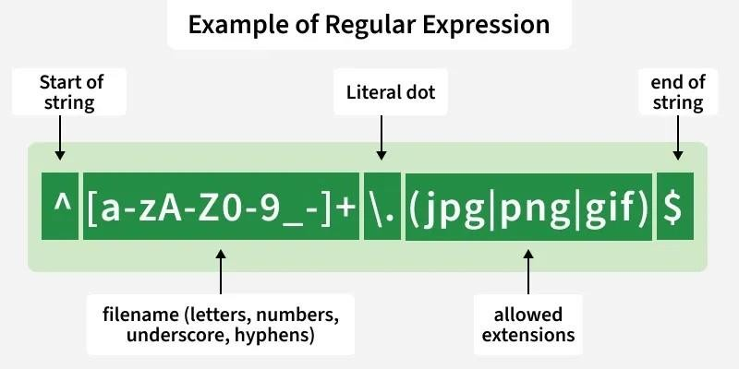

Above image shows an example of a regular expression and explains its parts, helping you understand how filenames or patterns can be matched effectively.

This regex checks if a filename is valid, allowing letters, numbers, underscore, hyphens and ends with .jpg, .png or .gif.

Importance of Regular Expression
    - Efficient Pattern Matching: Quickly search for specific patterns in text or data without manual checking.
    - Data Validation: Validate inputs like email addresses, phone numbers, URLs, and passwords.
    - Text Manipulation: Perform search-and-replace operations across files or datasets effectively.
    - Automation in Analytics and Tools: Used in tools like Google Analytics for URL matching and filtering.
    - Cross-Platform Support: Works across programming languages and editors such as Python, Java, Sublime Text, Notepad++, and Microsoft Word.

Common Elements Used in Regular Expressions
Regular expressions are built using special symbols and characters. Below are the most commonly used regex elements explained with simple examples.
- Repeaters ( *, +, and { } ): Repeaters specify how many times the preceding character or group should appear.
- Asterisk symbol (*): Matches the preceding character 0 or more times. Example: The regular expression ab*c will give ac, abc, abbc, abbbc….and so on
- The Plus symbol (+): Matches the preceding character 1 or more times. Example: The regular expression ab+c will give abc, abbc, abbbc, … and so on.
- The curly braces { … }: Defines an exact or range of repetitions.
Example: {{2}: exactly 2 times
{min,}: at least min times
{min,max}: between min and max times
- Wildcard (.): Matches any single character except a newline.
Example: Regular expression .* will tell the computer that any character can be used any number of times.
- Optional character (?): Matches 0 or 1 occurrence of the preceding character.
Example: docx? matches doc and docx

- The caret ( ^ ) symbol: Ensures the match starts at the beginning of the string.
Example : ^\d{3} matches 901 in 901-333
- The dollar ( $ ) symbol: Ensures the match ends at the end of the string.
Example: \d{3}$ matches 333 in 901-333
- Character Classes: Match specific types of characters:
\s: whitespace
\S: non-whitespace
\d: digit
\D: non-digit
\w: word character (letters, digits, _)
\W: non-word character
\b: word boundary
Example: [abc] matches a, b, or c
- Negated Character Class ([^ ]): Matches characters not listed in the brackets.
Example : [^abc] -> matches any character except a, b, c

Patterns

NLP (Natural Language Processing) helps in the extraction of valuable insights from large amounts of text data. Python has a wide range of libraries specifically designed for text analysis helps in making it easier for data scientists and analysts to process, analyze and derive meaningful insights from text. These libraries handle various NLP tasks such as text preprocessing, tokenization, sentiment analysis, named entity recognition and topic modeling. By using these libraries we can automate text analysis, uncover patterns and make informed, data-driven decisions.

Pattern
Pattern is a simple library for NLP and web mining with features like part-of-speech tagging and sentiment analysis. It is useful for small projects and learning about NLP.
- POS Tagging: Classify words in a sentence into grammatical categories like nouns, verbs or adjectives.
- Sentiment Analysis: Find whether the sentiment of text is positive, negative or neutral.

Real-life applications
    - Basic Text Processing: Analyze small datasets for sentiment classification or part-of-speech tagging.
    - Web Scraping: Extract text from websites for further analysis or research.

Words

Word Embeddings in NLP
Word Embeddings are numeric representations of words in a lower-dimensional space, that capture semantic and syntactic information. They play a important
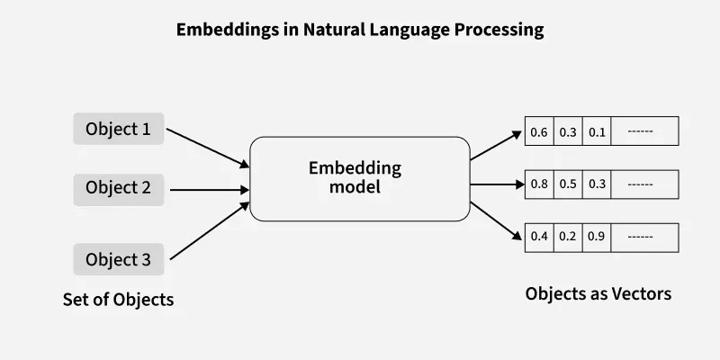
role in Natural Language Processing (NLP) tasks.

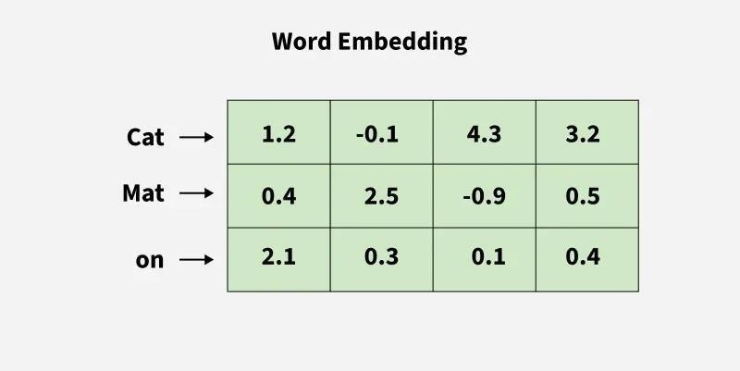

Word Embedding is an approach for representing words and documents. Word Embedding or Word Vector is a numeric vector input that represents a word in a lower-dimensional space.
- Method of extracting features out of text so that we can input those features into a machine learning model to work with text data.
- It allows words with similar meanings to have a similar representation. Thus, Similarity can be assessed based on Similar vector representations.
- High Computation Cost: Large input vectors will mean a huge number of weights. Embeddings help to reduce dimensionality.
- Preserve syntactical and semantic information.
- Some methods based on Word Frequency are Bag of Words(BOW), Count Vectorizer and TF-IDF.

Need for Word Embedding?
- To reduce dimensionality.
- To use a word to predict the words around it.
- Helps in enhancing model interpretability due to numerical representation.
- Inter-word semantics and similarity can be captured.

How are Word Embeddings used?
- They are used as input to machine learning models.
Words ----> Numeric representation > Use in Training or Inference.
- To represent or visualize any underlying patterns of usage in the corpus that was used to train them.

Approaches for Text Representation Corpora
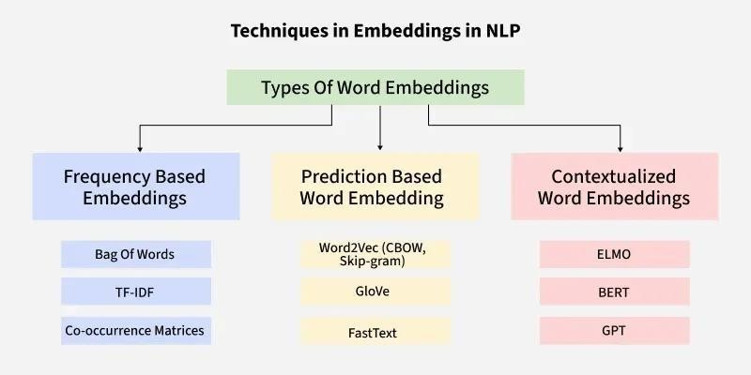

Corpora can be essential in text analysis because they can provide the raw data needed to perform the analyses. Quanteda can include access to several built-in corpora and it can allow the users to load and analyze their collections of the texts.

Accessing Available Corpora
Quanteda comes with several pre-built corpora, which can be accessed directly within the R. These corpora can typically used for demonstrations, testing, or preliminary analysis. To access these corpora, we can use the data_corpus_* functions provided by the Quanteda.
Commonly used corpora in Quanteda include:
- data_corpus_inaugural: It can be texts of the US Presidential Inaugural Addresses.
- data_corpus_irishbudget2010: it can be texts of the Irish budget speeches from 2010.
- data_corpus_udhr: It can be texts of the Universal Declaration of Human Rights in the various languages.

Using Corpora in Text Analysis
Once we have accesses the corpus, we can use it in the various text analysis tasks. Common analyses include:
- Tokenization: It can be breaking down the text into the individual words or terms.
- N-grams: Creating the sequences of the n consecutive words.
- Sentiment Analysis: It can determining the emotional tone behind the body of the text.
- Text Classification: It can be categorizing the texts into the predefined categories.

Text normalization

Natural Language Processing (NLP) is a field of artificial intelligence that focuses on the interaction between computers and human language. One of the fundamental tasks in NLP is text normalization, which includes converting words into their base or root forms. This process is essential for various applications such as search engines, text analysis, and machine learning.

Lemmatization and stemming are two common techniques used for this purpose.

What is Lemmatization?
Lemmatization is the process of reducing words to their base or dictionary form, known as the lemma. This technique considers the context and the meaning of the words, ensuring that the base form belongs to the language's dictionary. For example, the words "running," "ran," and "runs" are all lemmatized to the lemma "run."

How Lemmatization Works?
Lemmatization involves several steps:
    - Part-of-Speech (POS) Tagging: Identifying the grammatical category of each word (e.g., noun, verb, adjective).
    - Morphological Analysis: Analyzing the structure of the word to understand its root form.
    - Dictionary Lookup: Using a predefined vocabulary to find the lemma of the word.
For example, the word "better" would be lemmatized to "good" if it is identified as an adjective, whereas "running" would be lemmatized to "run" if identified as a verb.

Techniques in Lemmatization
- Rule-Based Lemmatization: Uses predefined grammatical rules to transform words. For instance, removing the "-ed" suffix from regular past tense verbs.
- Dictionary-Based Lemmatization: Looks up words in a dictionary to find their base forms.
- Machine Learning-Based Lemmatization: Employs machine learning models trained on annotated corpora to predict the lemma of a word.

Advantages and Disadvantages of Lemmatization Benefits:
  - Accuracy: Lemmatization provides more accurate results because it considers the context and meaning of words.
  - Standardization: Ensures words are reduced to their dictionary form, aiding in tasks like text normalization and information retrieval.

Limitations:
  - Complexity: Requires more computational resources and a comprehensive dictionary.

  - Dependency on POS Tagging: Requires accurate POS tagging, which adds to the processing overhead.

What is Stemming?
Stemming is a more straightforward process that cuts off prefixes and suffixes (i.e., affixes) to reduce a word to its root form. This root form, known as the stem, may not be a valid word in the language. For example, the words "running," "runner," and "runs" might all be stemmed to "run" or "runn," depending on the stemming algorithm used.

How Stemming Works?
Stemming algorithms apply a series of rules to strip affixes from words. The most common stemming algorithms include:
- Porter Stemmer: Uses a set of heuristic rules to iteratively remove suffixes.
- Snowball Stemmer: An extension of the Porter Stemmer with more robust rules.
- Lancaster Stemmer: A more aggressive stemmer that can sometimes over-stem words.
For example, the words "running", "runner", and "runs" might all be reduced to "run" by a stemming algorithm, but sometimes it might also reduce "arguing" to "argu".

Advantages and Disadvantages of Stemming Benefits:
  - Simplicity: Stemming is straightforward and computationally inexpensive.
  - Speed: Faster processing time due to simple rules and lack of context consideration.

Limitations:
  - Accuracy: Can produce stems that are not actual words, leading to less accurate results.
  - Over-Stemming: Can sometimes strip too much off a word (e.g., "running" to "runn").
  - Under-Stemming: Can sometimes strip too little off a word (e.g., "running" to "run").

When to Use Lemmatization vs. Stemming
The choice between lemmatization and stemming depends on the specific requirements of the NLP task at hand:

Use Lemmatization When:
    - Accuracy and context are crucial.
    - The task involves complex language understanding, such as chatbots, sentiment analysis, and machine translation.
    - The computational resources are sufficient to handle the additional complexity.

Use Stemming When:
    - Speed and efficiency are more important than accuracy.
    - The task involves simple text normalization, such as search engines and information retrieval systems.
    - The computational resources are limited

Minimum edit distance

Given two strings s1 and s2 and below operations that can be performed on s1. The task is to find the minimum number of edits (operations) to convert 's1' into 's2'.
    - Insert: Insert any character before or after any index of s1
    - Remove: Remove a character of s1
    - Replace: Replace a character at any index of s1 with some other character.
Note: All of the above operations are of equal cost.

Examples:
Input: s1 = "geek", s2 = "gesek"

Output: 1
Explanation: We can convert s1 into s2 by inserting an 's' between two consecutive 'e' in s1.
Input: s1 = "gfg", s2 = "gfg"

Output: 0
Explanation: Both strings are same.

Real-World Applications of Edit Distance
    - Spell Checking and Auto-Correction
    - DNA Sequence Alignment
    - Plagiarism Detection
    - Natural Language Processing
    - Version Control Systems

    - String Matching

Edit Distance and Longest Common Subsequence
If we do not consider the replace operation, then edit distance problem is same as the Longest Common Subsequence (LCS) problem. With only insert and delete operations allowed, the edit distance between two strings is ( M + N - 2* LCS)

Regular Language and FSAs

Regular Languages (RLs) and Finite Automata (FAs) in NLP, are fundamental for pattern matching in text, with RLs being languages recognized by FAs (like DFAs/NFAs) and described by Regular Expressions (Regex) or grammars, used for tasks like tokenization, lexical analysis, and identifying simple word patterns, forming the basis of early NLP techniques before complex neural models.

Regular Languages (RLs)
    - Definition: A class of languages defined by predictable patterns that can be recognized by FAs.
    - Representations: Can be expressed using Finite Automata (FA), Regular Expressions (Regex), or Regular Grammar.
    - Properties: Closed under union, concatenation, and Kleene star (e.g., a* for zero or more 'a's).
    - NLP Use: Identifying simple word forms (e.g., email formats, numbers), tokenization, and stemming/lemmatization rules.

Finite Automata (FAs)
    - Definition: Abstract machines with states and transitions that read input symbols to decide if a string matches a pattern.
    - Types: Deterministic Finite Automata (DFA) and Non-deterministic Finite Automata (NFA).
    - Role: Convert abstract Regex patterns into concrete machines for efficient text processing.

Regular Expressions (Regex)
    - Definition: A compact symbolic notation to describe patterns (e.g., a|b, a*, . for any character).
    - Conversion: Regex can be converted into FAs (both NFA and DFA).

Application in NLP

    - Lexical Analysis: Tokenizing text into meaningful units (words, punctuation) using regex and FAs.
    - Text Preprocessing: Removing noise, stopping words, or normalizing text.
    - Pattern Matching: Finding specific word structures or data formats (like dates, URLs).

Raw Text Extraction and Tokenization

Tokenization is a fundamental step in Natural Language Processing (NLP). It involves dividing a Textual input into smaller units known as tokens. These tokens can be in the form of words, characters, sub-words, or sentences. It helps in improving interpretability of text by different models.

What is Tokenization in NLP?
Natural Language Processing (NLP) is a subfield of AI, information engineering, and human-computer interaction. It focuses on how to process and analyze large amounts of natural language data efficiently. It is difficult to perform as the process of reading and understanding languages is far more complex than it seems at first glance.
    - Tokenization is a foundation step in NLP pipeline that shapes the entire workflow.
    - Involves dividing a string or text into a list of smaller units known as tokens.
    - Uses a tokenizer to segment unstructured data and natural language text into distinct chunks of information, treating them as different elements.
    - Tokens: Words or Sub-words in the context of natural language processing. Example: A word is a token in a sentence, A character is a token in a word, etc.
    - Application: Multiple NLP tasks, text processing, language modelling, and machine translation.

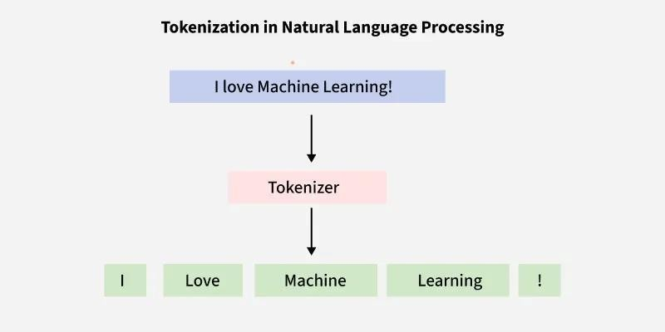

Types of Tokenization
Tokenization can be classified into several types based on how the text is segmented. Here are some types of tokenization:

Word Tokenization
Word tokenization is the most commonly used method where text is divided into individual words. It works well for languages with clear word boundaries, like English. For example, "Machine learning is fascinating" becomes:
Input before tokenization: ["Machine Learning is fascinating"]
Output when tokenized by words: ["Machine", "learning", "is", "fascinating"]

Character Tokenization
In Character Tokenization, the textual data is split and converted to a sequence of individual characters. This is beneficial for tasks that require a detailed analysis, such as spelling correction or for tasks with unclear boundaries. It can also be useful for modelling character-level language.

Example
Input before tokenization: ["You are helpful"]
Output when tokenized by characters: ["Y", "o", "u", " ", "a", "r", "e", " ",
"h", "e", "l", "p", "f", "u", "l"]

Sub-word Tokenization
This strikes a balance between word and character tokenization by breaking down text into units that are larger than a single character but smaller than a full

word. This is useful when dealing with morphologically rich languages or rare words.

Example
["Time", "table"]
["Rain", "coat"]
["Grace", "fully"]
["Run", "way"]
Sub-word tokenization helps to handle out-of-vocabulary words in NLP tasks and for languages that form words by combining smaller units.

Sentence Tokenization
Sentence tokenization is also a common technique used to make a division of paragraphs or large set of sentences into separated sentences as tokens. This is useful for tasks requiring individual sentence analysis or processing.
Input before tokenization: ["Artificial Intelligence is an emerging technology. Machine learning is fascinating. Computer Vision handles images. "]
Output when tokenized by sentences ["Artificial Intelligence is an emerging technology.", "Machine learning is fascinating.", "Computer Vision handles images."]

N-gram Tokenization
N-gram tokenization splits words into fixed-sized chunks (size = n) of data.
Input before tokenization: ["Machine learning is powerful"]
Output when tokenized by bigrams: [('Machine', 'learning'), ('learning', 'is'), ('is', 'powerful')]

Need of Tokenization
Tokenization is an essential step in text processing and natural language processing (NLP) for several reasons. Some of these are listed below:
  - Effective Text Processing: Reduces the size of raw text, resulting in easy and efficient statistical and computational analysis.
  - Feature extraction: Text data can be represented numerically for algorithmic comprehension by using tokens as features in ML models.
  - Information Retrieval: Tokenization is essential for indexing and searching in systems that store and retrieve information efficiently based on words or phrases.
  - Text Analysis: Used in sentiment analysis and named entity recognition, to determine the function and context of individual words in a sentence.
  - Vocabulary Management: Generates a list of distinct tokens, Helps manage a corpus's vocabulary.

Task-Specific Adaptation: Adapts to need of particular NLP task, Good for summarization and machine translation.

Extracting Terms from Tokens

Keyword extraction is a vital task in Natural Language Processing (NLP) for identifying the most relevant words or phrases from text, and enhancing insights into its content. The article explores the basics of keyword extraction, its significance in NLP, and various implementation methods using Python libraries like NLTK, TextRank, RAKE, YAKE, and KeyBERT.
Keyword extraction is a technique used to identify and extract the most relevant words or phrases from a piece of text. The significance of keyword extraction in natural language processing (NLP) discussed below:
    - Information Retrieval: Keywords function as queries to retrieve pertinent items from extensive text collections or databases.
    - Document summarization involves utilizing extracted keywords to create succinct summaries of documents, effectively encapsulating their fundamental substance.
    - Text categorization and classification involve the use of keywords to determine the primary subjects or categories of documents, which aids in the process of classifying them.
    - Search Engine Optimization (SEO): Keywords are essential for enhancing the visibility and ranking of site content in search engine results pages.
    - Keyword extraction is an essential stage in topic modeling techniques as it aids in identifying the fundamental themes or topics present in a collection of documents.

Libraries Required for Keyword Extraction
    - NLTK: provides a range of modules for text processing. These modules include routines for TF-IDF and TextRank-based keyword extraction.
    - YAKE library: offers a Python version of the YAKE algorithm, which is used for unsupervised keyword extraction.
    - RAKE is not a library, but it may be constructed easily using Python's string manipulation tools and basic text processing techniques.

    - KeyBert: It works on a transformer model (BERT) which uses bert embeddings to identify the most similar keywords and phrases within a large document.

KeyWord Extraction using TestRank
TestRank is an algorithm used for keyword extraction in the context of natural language processing (NLP) and information retrieval. It was developed to improve upon traditional methods of keyword extraction by considering the structure and content of a document in a more relevant way.
    - Text Preprocessing: The algorithm starts by preprocessing the text, which involves tasks like tokenization (breaking the text into words or phrases), removing stop words (common words like "the," "and," "is" that don't carry significant meaning), and possibly stemming or lemmatization (reducing words to their root form).
    - Building a Graph: TestRank constructs a graph representation of the text, where nodes represent words or phrases, and edges represent relationships between them. These relationships could be based on co-occurrence within sentences or paragraphs, semantic similarity, or other linguistic features.
    - Scoring Nodes: Each node (word or phrase) in the graph is assigned a score based on various factors. TestRank typically considers factors such as the node's degree (how many other nodes it is connected to), its centrality within the graph, its position within the document, and possibly its semantic relevance to the overall content.
    - Ranking Keywords: After scoring all nodes in the graph, TestRank ranks them based on their scores. The highest-scoring nodes are considered the most important keywords or phrases in the document.
    - Keyword Extraction: Finally, TestRank selects the top-ranked nodes as the extracted keywords for the document. These keywords are representative of the main themes or topics discussed in the text.

2.0 Normalization

Natural Language Processing (NLP) is a field of artificial intelligence that focuses on the interaction between computers and human language. One of the fundamental tasks in NLP is text normalization, which includes converting words into their base or root forms. This process is essential for various applications such as search engines, text analysis, and machine

learning. Lemmatization and stemming are two common techniques used for this purpose.

What is Lemmatization?
Lemmatization is the process of reducing words to their base or dictionary form, known as the lemma. This technique considers the context and the meaning of the words, ensuring that the base form belongs to the language's dictionary. For example, the words "running," "ran," and "runs" are all lemmatized to the lemma "run."

How Lemmatization Works?
Lemmatization involves several steps:
- Part-of-Speech (POS) Tagging: Identifying the grammatical category of each word (e.g., noun, verb, adjective).
- Morphological Analysis: Analyzing the structure of the word to understand its root form.
- Dictionary Lookup: Using a predefined vocabulary to find the lemma of the word.
For example, the word "better" would be lemmatized to "good" if it is identified as an adjective, whereas "running" would be lemmatized to "run" if identified as a verb.

Techniques in Lemmatization
- Rule-Based Lemmatization: Uses predefined grammatical rules to transform words. For instance, removing the "-ed" suffix from regular past tense verbs.
- Dictionary-Based Lemmatization: Looks up words in a dictionary to find their base forms.
- Machine Learning-Based Lemmatization: Employs machine learning models trained on annotated corpora to predict the lemma of a word.

Advantages and Disadvantages of Lemmatization Benefits:
  - Accuracy: Lemmatization provides more accurate results because it considers the context and meaning of words.
  - Standardization: Ensures words are reduced to their dictionary form, aiding in tasks like text normalization and information retrieval.

Limitations:
  - Complexity: Requires more computational resources and a comprehensive dictionary.

  - Dependency on POS Tagging: Requires accurate POS tagging, which adds to the processing overhead.

What is Stemming?
Stemming is a more straightforward process that cuts off prefixes and suffixes (i.e., affixes) to reduce a word to its root form. This root form, known as the stem, may not be a valid word in the language. For example, the words "running," "runner," and "runs" might all be stemmed to "run" or "runn," depending on the stemming algorithm used.

How Stemming Works?
Stemming algorithms apply a series of rules to strip affixes from words. The most common stemming algorithms include:
- Porter Stemmer: Uses a set of heuristic rules to iteratively remove suffixes.
- Snowball Stemmer: An extension of the Porter Stemmer with more robust rules.
- Lancaster Stemmer: A more aggressive stemmer that can sometimes over-stem words.
For example, the words "running", "runner", and "runs" might all be reduced to "run" by a stemming algorithm, but sometimes it might also reduce "arguing" to "argu".

Advantages and Disadvantages of Stemming Benefits:
  - Simplicity: Stemming is straightforward and computationally inexpensive.
  - Speed: Faster processing time due to simple rules and lack of context consideration.

Limitations:
  - Accuracy: Can produce stems that are not actual words, leading to less accurate results.
  - Over-Stemming: Can sometimes strip too much off a word (e.g., "running" to "runn").
  - Under-Stemming: Can sometimes strip too little off a word (e.g., "running" to "run").

MODULE 3: N-GRAM LANGUAGE MODELS

N-grams
N-grams in NLP are continuous sequences of 'n' items (words, characters) from text, used to understand patterns, predict text (autocomplete), model language, and power applications like speech recognition and machine translation by calculating probabilities of word/character orders, moving beyond single words to capture context. They range from Unigrams (single words) to Bigrams (pairs) to Trigrams (triplets), revealing structure for tasks like spelling correction and text classification.

What are N-grams?
    - Definition: A sequence of 'n' adjacent items (tokens) from a text corpus, where 'n' is the size of the sequence.

Examples:
      - Unigram (n=1): "I", "love", "NLP".
      - Bigram (n=2): "I love", "love NLP".
      - Trigram (n=3): "I love NLP".

How are they used in NLP?
    - Language Modeling: Predict the probability of the next word given the previous n-1 words (e.g., predicting "bear" after "sweet" in "sweet bear" vs. "sweet bare").
    - Text Prediction & Autocomplete: Suggest words or phrases based on common sequences.
    - Speech Recognition: Resolve ambiguities (e.g., "to" vs. "too") by checking sentence likelihood.
    - Machine Translation: Generate more natural-sounding translations.
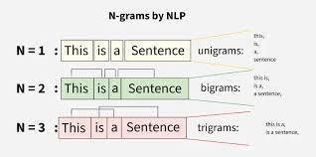
    - Text Mining & Classification: Identify patterns, classify documents, or check spellings (e.g., "minuets" in "fifteen minutes")

Evaluating language models
- Intrinsic Evaluation
Intrinsic evaluation measures the quality of a model in isolation, independent of any specific downstream application. It often uses a held-out test dataset to assess how well the model predicts the test data.
Common intrinsic metrics include:
  - Perplexity (PPL): A widely used metric that quantifies how uncertain a model is about the predictions it makes. A lower perplexity score indicates a better model, as it is less "surprised" by the test sample.
  - Entropy and Cross-Entropy: Related to perplexity, these metrics measure the average number of bits required to encode a word or character, with lower values indicating a more accurate model.

Extrinsic (Task-Based) Evaluation
Extrinsic evaluation assesses the language model's performance by embedding it within a real-world application (e.g., machine translation, question answering, or sentiment analysis) and measuring how much the application's overall performance improves. This end-to-end evaluation provides a better understanding of the model's practical utility.

Automated Metrics for Generated Text
For tasks that involve text generation (like summarization or translation), several metrics compare the model's output to one or more human-written reference texts:
  - BLEU (Bilingual Evaluation Understudy): Primarily used in machine translation, BLEU scores measure the n-gram overlap between the generated and reference texts, focusing on precision.
  - ROUGE (Recall-Oriented Understudy for Gisting Evaluation): Commonly used for text summarization, ROUGE metrics (ROUGE-1, ROUGE-2, ROUGE-L) assess the recall of n-grams or longest common subsequences from the reference text.
  - BERTScore / MoverScore: These are embedding-based metrics that use contextual embeddings (e.g., from BERT) to measure the semantic similarity between the generated and reference sentences, which often correlates better with human judgment than simple overlap metrics.

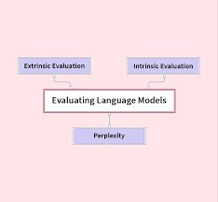

Generalization and zeros
Generalization is a model's ability to perform well on new, unseen data, avoiding overfitting, while "Zeros" refer to two key concepts: zero-frequency issues (unseen word combinations causing zero probability) and Zero-Shot Learning (ZSL), where models tackle tasks without examples, leveraging learned knowledge for broad applicability. Zeros are tackled via techniques like smoothing (e.g., Add-One) to handle unseen word pairs and by designing models (like large transformers) to understand linguistic structure for zero-shot tasks, bridging the gap between limited training data and real-world linguistic diversity.

Generalization in NLP
    - Definition: The core goal of NLP, enabling models to apply learned patterns from training data to novel, real-world data from the same distribution.
    - Challenge: Models often overfit (memorize training data) or underfit (fail to capture patterns), hindering generalization.
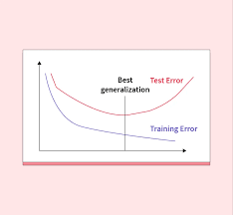
    - Evaluation: Researchers use taxonomies (data shifts, sources) to understand and improve generalization across different scenarios, from semantic understanding to new domains.

55

Kneser-Ney (KN) smoothing in NLP
It is a powerful technique for estimating n-gram probabilities (word sequences) in language models, especially for rare or unseen sequences, by using absolute discounting and a clever concept called continuation probability, which accounts for how many different contexts a word appears in, rather than just its raw frequency, improving predictions in speech recognition and machine translation. It works by taking probability mass from observed n-grams and redistributing it to unseen ones, using a unique formula that considers the diversity of word contexts, making it superior to simpler methods like Laplace smoothing.
Core Concepts
    - N-grams: Sequences of 'n' words, e.g., a bigram (two words) or trigram (three words).
    - Smoothing: Adjusting probability estimates to handle zero counts for unseen n-grams, preventing models from assigning zero probability to valid but rare events.
    - Absolute Discounting: Subtracting a small, fixed discount (e.g., 0.75) from the counts of observed n-grams.
    - Continuation Probability (Kneser-Ney's key idea): Instead of just using a word's unigram probability (how often it appears), KN uses its "continuation probability" – how often a word acts as a novel continuation to a new context. This is calculated by counting how many different preceding words (types) a given word completes.
How it Works (Simplified)
- Discount Observed N-grams: For a trigram
𝑃(𝑤₃|𝑤₁, 𝑤₂)
, you take its observed count, subtract a discount (e.g., 0.75), and divide by the count of the preceding bigram
(𝑤2)
- Back-off to Lower Order: If the trigram wasn't seen, you "back off" to the bigram
𝑃(𝑤₃|𝑤₂)
- Interpolate with Continuation: The discounted probability is then interpolated with the lower-order probability (e.g.,
𝑃(𝑤3|𝑤2) but this lower-order term uses the novel continuation probability of

completes) multiplied by a weight (𝜆
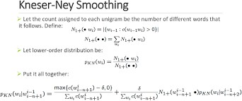
- Calculate Weights (𝜆): The weights ensure that all probabilities sum to one, effectively distributing the "discounted mass" to unseen n-grams.

Huge language models and stupid back off.
Huge Language Models (LLMs) handle massive data, but still face the
data sparsity problem (unseen word combos), leading to "zero-probability" issues in traditional methods; Stupid Backoff, from Google's translation work, solves this efficiently by using a simple, weighted fallback to shorter contexts (e.g., trigram to bigram) when a longer phrase isn't found, assigning a constant (like 0.4) instead of complex probability mass redistribution, making it fast and effective for web-scale datasets, often beating more complex methods.
How Stupid Backoff Works
- Check Higher Order: First, check the probability of the full N-gram (e.g., trigram: "a sunny day") using Maximum Likelihood Estimation (MLE) (count of trigram / count of prefix).
- Back Off: If the count is zero (unseen), back off to the next lower order (bigram: "sunny day").
- Apply Weight: Multiply the lower-order's score by a constant weight (e.g.,

𝛼 = 0.4
𝛼=0.4
).
- Repeat: If that's also zero, back off again (e.g., to unigram "day"), multiplying by the weight again, until a count is found or you reach the unigram.
Why It's Used with Huge Models

  - Efficiency: Calculating true probabilities for billions of N-grams (like in web-scale models) is computationally expensive. Stupid Backoff avoids complex discounting (like Kneser-Ney) and normalization.
  - Performance: Despite its simplicity (it doesn't produce true probabilities, just scores), it performs remarkably well, often matching or exceeding sophisticated methods on massive datasets.
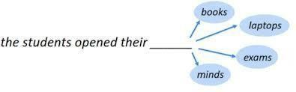
  - Scalability: It's well-suited for handling the vast data found in web corpora, allowing models with billions of N-grams to be built and used quickly for tasks like Machine Translation.

Perplexity’s relation to Entropy

Perplexity measures how well a language model predicts text, directly linked to Entropy by being its exponent (𝑃𝑃 = 𝑏𝐻), where 𝑏is the logarithm base (usually 2). While entropy quantifies the inherent uncertainty/information in a language, perplexity translates that into an intuitive "number of choices" (e.g., a perplexity of 10 means the model is as confused as if it had 10 equally likely options for the next word). Lower perplexity indicates better model performance, reflecting lower cross-entropy and closer alignment with the true data distribution.
Key Relationships
    - Entropy (H): Measures average uncertainty in bits (or other units) for a true distribution.
    - Cross-Entropy (H(p,q)): Measures the average bits needed to encode data from true distribution 'p' using a model 'q'; it's always ≥true entropy.
    - Perplexity (PP): The exponential of cross-entropy (𝑃𝑃 = 𝑏𝐻(𝑝,𝑞)). It signifies the weighted average number of choices a model has for the next token.

1 ∑𝑁 𝑙𝑜g2𝑃(w𝑖|w 𝑖)
−
𝑃𝑃(𝑊) = 2 𝑁 𝑖=1 <

𝑃𝑃(𝑊) = 𝑒𝑥𝑝(𝐻(𝑊)
(when using natural log). How it Works in NLP
- Model Prediction: A language model assigns probabilities to possible next words given a context.
- Calculate Cross-Entropy: The model's predicted probabilities (q) are compared to the actual next word (p) using cross-entropy.
- Exponentiate for Perplexity: This cross-entropy value is then exponentiated (usually by base 2) to get perplexity.
- Interpretation: A low perplexity score means the model is less "perplexed" and more confident/accurate in its predictions, effectively acting like it's choosing from fewer likely words.
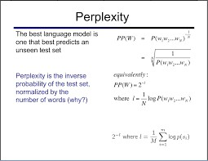

Inflection
inflection is the modification of a word to express different grammatical categories such as tense, case, and number. Processing inflection is a core part of morphological analysis, which helps computers understand the structure and meaning of words in human language.

Understanding Inflection in NLP
Inflection involves adding suffixes, prefixes, or making internal changes to a base word (lemma or stem) without changing its fundamental meaning or part of speech.
Common English inflectional morphemes (suffixes) include:
    - Plural -s: dog → dogs

    - Past Tense -ed: walk → walked
    - Present Participle -ing: play → playing
    - Third-person singular -s: he run → he runs
    - Comparative -er: hot → hotter
In contrast, derivational morphology creates new words by changing the part of speech or adding substantial meaning (e.g., happy (adjective)
→ happiness (noun)).

NLP Techniques for Handling Inflection
NLP systems must account for inflection to process language effectively. Two primary techniques are used to reduce inflected words to a common base form:
    - Stemming: This is a heuristic process that lops off the ends of words to their "stem," which might not be a valid word itself. It is generally faster and used in applications like information retrieval systems, where the goal is to group related word forms together. For example, stemming fishing, fished, and fisher might all yield the stem fish.
    - Lemmatization: This more sophisticated process considers the context and uses a dictionary to return the word to its meaningful base form, known as the lemma. For example, lemmatization would correctly map caring to the verb care, whereas stemming might incorrectly cut it to car.
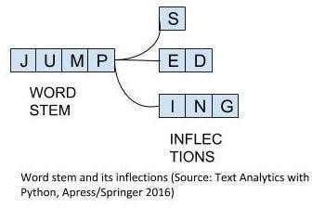

Derivational Morphology
Derivational Morphology in NLP involves computational techniques to analyze how new words (lexemes) are formed by adding prefixes/suffixes (morphemes) that change meaning or part of speech (e.g., happy -
> happiness), contrasting with inflection (e.g., run -> running). NLP uses this for tasks like improving machine translation, text analysis, and

building language models, employing methods like rule-based systems, stemming (e.g., Porter), or data-driven subword tokenization (Byte Pair Encoding/BPE) to break words into roots and affixes, revealing deeper linguistic patterns.

Key Concepts
    - Derivational Morphology: Creating new words (e.g., un-
+ kind = unkind) or changing their word class (e.g., beauty + - ful = beautiful).
    - Inflectional Morphology: Modifying words for grammatical context (tense, number, etc.) without changing meaning (e.g., walk -
> walked, dog -> dogs).
    - Morpheme: The smallest meaningful unit (root, prefix, suffix).
    - Stemming/Lemmatization: Reducing words to their base/root form (e.g., running -> run).

NLP Techniques for Derivation
    - Rule-Based Systems: Using linguistic rules to identify patterns (e.g., adjective + -ness = noun).
    - Stemming Algorithms: Like Porter, removing suffixes to find roots, though sometimes over-simplifies.

Data-Driven Methods (Subword Tokenization):
      - BPE (Byte Pair Encoding): Merges frequent character sequences to form subwords, useful for LLMs like GPT.
      - Word Pieces: Similar to BPE, breaking rare words into parts (e.g., unbelievable -> un, believe, able).
    - Analogy-Based Methods: Modeling how new words are formed based on existing patterns, crucial for analogical generalization in LLMs.
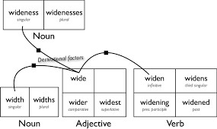

Finite-State Morphological Parsing

Finite-state morphological parsing in Natural Language Processing (NLP) is the process of breaking down words into their constituent morphemes (stems and affixes) and their grammatical features using Finite-State Transducers (FSTs).
How It Works
A Finite-State Transducer is an automaton that maps an input sequence (the surface form of a word as it appears in text) to an output sequence (its underlying lexical representation or morphological structure). This process relies on several key components:
    - Lexicon: A dictionary of valid stems (roots) and affixes (prefixes, suffixes).
    - Morphotactic Rules: Rules that define the legal order and combination of morphemes for a specific language (e.g., in English, a plural suffix follows a noun stem, as in "cats").
    - Orthographic Rules: Spelling rules that account for character changes when morphemes are combined (e.g., the change from 'y' to 'i' when adding '-es' to "fox" to form "foxes").
The FST is constructed to enforce these rules, effectively acting as both a recognizer (determining if a word is valid) and a generator (producing the morphological analysis).
Example:
For the word "unhappiness":
    - Input (Surface form): unhappiness
    - Output (Lexical form): un- +happy +ness or happy +ADJ +un- +ness +N

2.0 The Lexicon and Morphotactics
the lexicon is the vocabulary of a language, and morphotactics refers to the rules governing how the meaningful parts of words (morphemes) can be combined. Together, they are essential for morphological analysis, a foundational step in NLP that helps systems understand word structures.
The Lexicon in NLP
A lexicon in NLP is a dictionary-like resource that stores not just words (stems) but also their associated information, which is crucial for processing language efficiently.
Key information stored in a computational lexicon includes:
    - Stems and Affixes: A list of root forms (e.g., "cat", "walk") and affixes (e.g., "-s", "-ed", "un-").

    - Part of Speech (POS): Grammatical categories, such as noun, verb, or adjective, associated with each entry.
    - Morphological Information: Details about inflections (e.g., past tense, pluralization).
    - Semantic and Sentiment Information: The meaning of words, synonyms, or their emotional tone (positive/negative/neutral).
Morphotactics in NLP
Morphotactics provides the model for the allowable ordering and combination of morphemes within a word. It defines which classes of morphemes can follow one another.
    - Example Rule: In English, the plural morpheme ("-s") must follow a noun stem (e.g., "cats"), not precede it ("s-cat" is invalid).
    - Implementation: These rules are often modeled using Finite-State Automata (FSA) or Finite-State Transducers (FST).
    - Orthographic Rules: Morphotactics also incorporates spelling rules to handle changes when morphemes combine (e.g., city + -s becomes cities, not citys).
How They Are Used in NLP
The lexicon and morphotactics work in tandem for tasks such as:
    - Morphological Analysis: The process of breaking down a surface word form (e.g., "unhappiness") into its constituent morphemes and features (un- + happy + -ness).
    - Stemming and Lemmatization: Reducing words to their base or dictionary form, which improves tasks like information retrieval and search engines.
    - Part-of-Speech Tagging: Accurately identifying the grammatical role of each word in a sentence.
    - Machine Translation: Ensuring correct word forms are generated in the target language.

Morphological Parsing with Finite State Transducers(FSTs) Morphological parsing with Finite State Transducers (FSTs) in NLP is a technique to break words into meaningful parts (morphemes
like stems, prefixes, suffixes) by mapping surface word forms to their lexical representations,
using FSTs as powerful state machines to handle complex spelling rules (orthography) and combination rules (morphotactics) in a cascade. It's a classic method for analyzing morphologically rich languages or handling

63

new words, though modern neural models sometimes replace it for data-rich languages, FSTs remain fundamental for understanding linguistic structures.

How it Works
- Two-Level Morphology: Words are seen as correspondences between a surface level (actual spelling, e.g., "cats") and a lexical level (morpheme + features, e.g., cat+N+PL).
- Lexicon: A dictionary of stems (like cat, run) and affixes (like s, ed, ing) with their features.
- Morphotactic Rules: Define valid sequences of morphemes (e.g., a past tense -ed can follow a verb stem, not another suffix).
- Orthographic Rules: Handle spelling changes (e.g., dropping 'e' before adding 'ing', doubling consonants).
- FST Construction: These rules and lexicons are compiled into an FST, which acts as a machine that reads the input word and generates the underlying analysis.
- Parsing (Mapping): The FST processes the word character-by-character, following transitions and potentially using "epsilon" (empty) transitions, to output the decomposed morphemes and their features.

2.1 Combining FST Lexicon and rules.
combining FSTs (Finite State Transducers) for lexicons and rules creates powerful morphological parsers by cascading FSTs for stems, affixes, and complex spelling changes (like consonant doubling) into one system, allowing words to be broken into morphemes (stem+features+affix) for tasks like lemmatization, even for unknown words, by using FSTs to map surface forms to lexical ones.

Key Components & How They Combine
- Lexical FSTs (Stems/Affixes): FSTs represent word roots (stems) and common affixes (prefixes/suffixes) with their features (e.g., run<V,
+Pres>).
- Rule FSTs (Orthography): Separate FSTs handle spelling changes (e.g., "fox" + "es" -> "foxes", "fly" + "s" -> "flies" with y-to-i change).
- Cascading: FSTs are linked in a pipeline; the output of one becomes the input for the next (e.g., Lexical FST output -> Rule FST).
- Composition: A more efficient method that combines multiple FSTs (lexicon + rules) into a single, complex FST, creating a unified morphological model.

The Process (Morphological Parsing)
  - Input: A surface word (e.g., "running").

64

MODULE IV: WORD SENSE DISAMBIGUATION

METHODOLOGICAL PRELIMINARIES
In everyday language, many words do not have a single fixed meaning. The meaning of a word often changes depending on the situation in which it is used. Humans understand this naturally, but for a computer, this becomes a challenge. Word Sense Disambiguation, or WSD, is the method used to help a computer decide the correct meaning of a word in a given context.
A word can have multiple senses, and each sense represents a different meaning. To identify the correct sense, the surrounding words and the overall sentence play an important role. This surrounding information is called context. Resources like dictionaries and WordNet are commonly used to list different meanings of words and support the disambiguation process.
Before applying WSD techniques, certain basic assumptions and concepts need to be understood. These methodological preliminaries help in clearly defining the problem and choosing suitable approaches. A clear understanding of these

66

Supervised Disambiguation: Bayesian classification
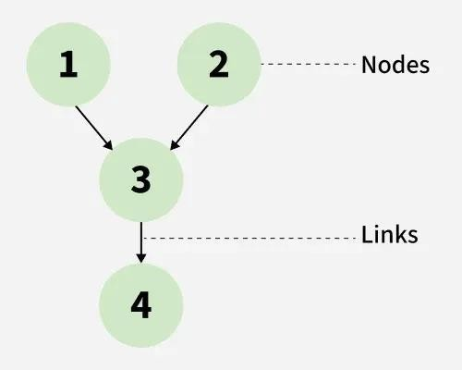
Bayes Classification is a Supervised machine learning approach for classification. It works on a probabilistic method which uses Bayes Theorem to be implemented. It predicts the data point label or assigns the class on the basis of heuristic and statistical data. Let's dive deep into Bayes Classification and its Differences from Naive Bayes Classification.

The above image denotes the relationship representation in a Bayes Classifier. The nodes represent features or variables in a Bayesian network. These can either be discrete or continuous. The links, on the other hand, denote the relationships between the nodes, along with a probability distribution over variables.

Key Features of Bayes Classifier Probabilistic Model:
    - Probabilistic Model: Based on conditional probability using Bayes' Theorem.
    - Supervised Learning Approach: Requires labeled training data.
    - Classifies Using Prior and Likelihood: Combines prior class probabilities with data likelihood.
    - Model Interpretability: Easy to interpret due to mathematical formulation. Scalability: Efficient for larger datasets.
    - Handles Continuous/Discrete Features: Works with both types depending on implementation.
66

An Information-Theoretic Approach
The information-theoretic approach to Word Sense Disambiguation is based on the idea that the correct meaning of a word is the one that provides the maximum amount of useful information in a given context. This approach uses concepts from information theory, such as probability and information content, to reduce uncertainty about a word’s meaning.
In this method, each possible sense of a word is assigned a probability based on how frequently it occurs and how well it fits the surrounding context. The sense that minimizes ambiguity and conveys the most information is selected as the correct one. In simple terms, the meaning that best explains the context is chosen.
This approach is effective because it models language mathematically and avoids relying only on fixed rules. By measuring uncertainty and information content, it helps systems make more accurate decisions. Information-theoretic methods are especially useful in large text corpora and are commonly applied in tasks like machine translation and information retrieval.
One of the key strengths of the information-theoretic approach is that it integrates naturally with probabilistic and statistical language models. It does not require handcrafted rules and can adapt well to different domains as long as sufficient data is available. Because of this, it is particularly suitable for large-scale Natural Language Processing systems that operate on massive text collections.
However, the approach also depends heavily on accurate probability estimation. If the probabilities of word senses or contextual features are poorly estimated, the reduction in uncertainty may be misleading. Despite this limitation, information-theoretic methods have played an important role in shaping modern WSD techniques and continue to influence current machine learning and neural approaches to semantic analysis.
In summary, the information-theoretic approach views Word Sense Disambiguation as a process of minimizing uncertainty and maximizing useful information. By applying concepts such as entropy, conditional entropy, and information gain, it provides a mathematically grounded framework for selecting the most appropriate meaning of a word in context.
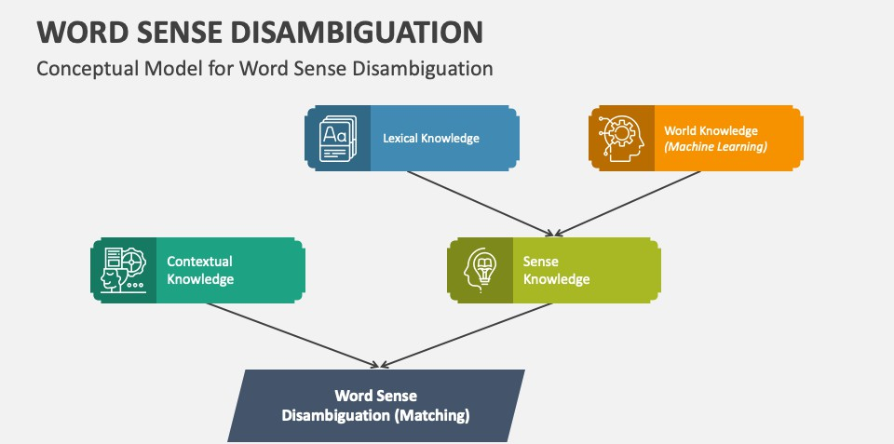

67

Disambiguation based on sense:
The ability to identify which meaning of a word is activated by its use in a specific context is known as word sense disambiguation in natural language processing (NLP). It is an important NLP technique for determining a word's meaning in a specific context. Determining a word's precise usage in a sentence has numerous applications, and NLP systems frequently struggle to correctly identify words.
High-accuracy POS taggers can resolve Word's syntactic ambiguity. WSD (word sense disambiguation) refers to the problem of resolving semantic ambiguity. The resolution of semantic ambiguity is more difficult than the resolution of syntactic ambiguity. Word Sense Disambiguation essentially resolves the ambiguity that occurs when determining the meaning of a word when it is used in various contexts.
Methods of Word Sense Disambiguation (WSD):
- Dictionary-based or Knowledge-based Methods: These techniques mainly rely on lexical databases, dictionaries, and treasures. They do not rely on corpora evidence for ambiguity. The Lesk method was the first to use a dictionary. Lesk defines it as "measure overlap between sense definitions of the word and current context," which means identifying the correct sense for one word at a time. This sentence or paragraph's surrounding words make up the current context in this case.
- Supervised Methods: These techniques presuppose that the context can provide sufficient proof on its own to clarify the meaning. The terms "knowledge" and "reasoning" are not considered necessary in these approaches. As a collection of word "features," the context is depicted. Along with that, it contains details about the words around it.
- Semi-supervised Methods: Most word sense disambiguation algorithms employ semi-supervised learning strategies due to the dearth of training corpora. This is because semi-supervised methods employ both labeled and unlabeled data. These methods necessitate very little annotated text and a large amount of plain unannotated text.
- Unsupervised Methods: Due to their independence from manual labor, unsupervised methods have enormous potential to break the knowledge acquisition bottleneck.
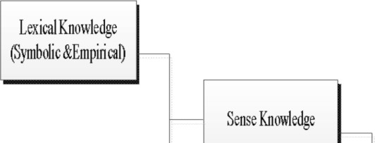

68

Thesarus-based Disambiguation
Thesaurus-based disambiguation is a knowledge-based approach to Word Sense Disambiguation that uses a thesaurus to determine the correct meaning of an ambiguous word. A thesaurus groups words according to similarity of meaning and provides information such as synonyms, related terms, and sometimes conceptual relationships. This semantic information is used to match the meaning of a word with its surrounding context.
In this approach, each possible sense of a word is represented by a set of related words obtained from the thesaurus. The context of the ambiguous word is also analyzed to identify important neighboring words. The system then compares the context words with the thesaurus entries of each sense. The sense whose related words have the highest overlap or strongest semantic similarity with the context is chosen as the correct meaning.
The basic assumption behind thesaurus-based disambiguation is that words occurring together in a sentence are semantically related. Therefore, if the surrounding words are closely connected to a particular sense of the ambiguous word in the thesaurus, that sense is likely to be correct. For example, in the sentence “He went to the bank to deposit money,” context words like deposit and money are closely related to the financial sense of bank, which can be confirmed using a thesaurus.
One advantage of this approach is that it does not require annotated training data. It relies on existing lexical resources, making it suitable when labeled corpora are unavailable. However, its performance depends heavily on the quality and coverage of the thesaurus. If the thesaurus lacks sufficient semantic relations or domain-specific terms, disambiguation accuracy may be limited.
In summary, thesaurus-based disambiguation resolves word ambiguity by measuring semantic similarity between the context and thesaurus-defined senses. It is a simple yet effective knowledge-based method and forms the foundation for more advanced semantic disambiguation techniques.
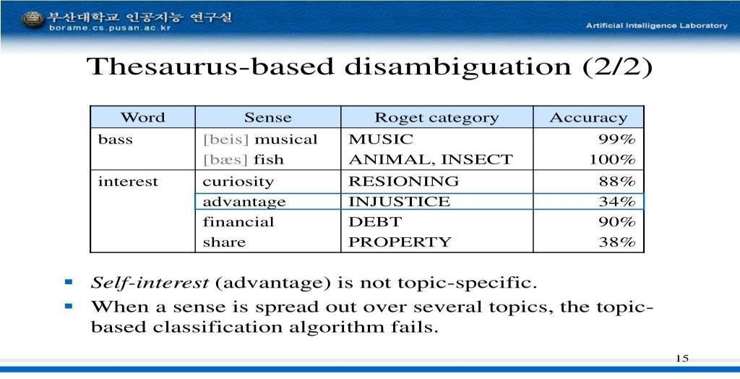

  - Disambiguation based on translations in a second-language corpus. Translation-based disambiguation is a knowledge- or corpus-based approach to Word Sense Disambiguation that relies on the use of a parallel or bilingual corpus—a collection of texts available in two languages. The main idea is that different senses of an ambiguous word in one language often translate into different words in another language. By analyzing these translations, the correct sense can be inferred.
In this approach, an ambiguous word in the source language is aligned with its translations in the target language. If a particular sense consistently maps to a specific translation, that translation can serve as a clue for disambiguation. For example, the English word “bank” has multiple senses:
- Financial institution → translated as “banque” in French
- Side of a river → translated as “rive” in French
If the English sentence “He went to the bank to deposit money” is translated into French, the presence of the word “banque” clearly identifies the financial sense.
This method benefits from actual usage patterns in context, since the corpus contains naturally occurring sentences. It is particularly useful when sufficient bilingual data is available, as the translations implicitly encode semantic distinctions between senses.

Advantages:
- Leverages real contextual usage across languages
- Can disambiguate senses without relying on hand-crafted rules
- Works well for languages with rich bilingual corpora

Limitations:
- Requires large and well-aligned parallel corpora
- May not work effectively for low-resource languages
- Translation ambiguity can introduce errors if a sense maps to multiple words in the target language
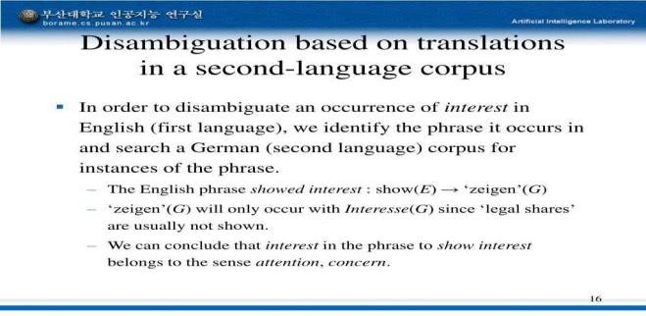
In summary, translation-based disambiguation uses cross-linguistic evidence to identify word senses. By observing how an ambiguous word is rendered in a second language, the correct sense can often be determined automatically. This approach connects lexical semantics with multilingual corpus analysis, making it valuable in machine translation and cross-lingual NLP applications.

MODULE 5 MARKOV MODEL AND POS TAGGING

Hidden Markov Model in Machine learning
To work with sequential data where the actual states are not directly visible, the Hidden Markov Model (HMM) is a widely used probabilistic model in machine learning. It assumes that a system moves through hidden states over time, and each hidden state produces an observable output based on certain probabilit Hidden Markov Model in Machine learning
To work with sequential data where the actual states are not directly visible, the
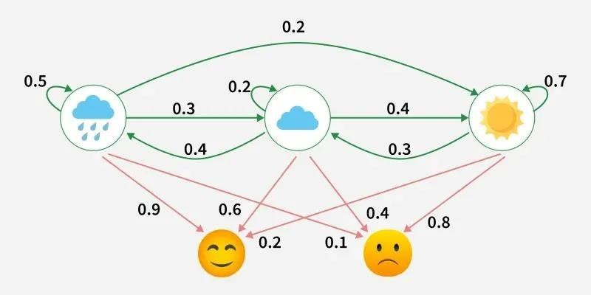
Hidden Markov Model (HMM) is a widely used probabilistic model in machine learning. It assumes that a system moves through hidden states over time, and each hidden state produces an observable output based on certain probabilities.
This example shows a Hidden Markov Model where the hidden states are weather conditions (Rainy, Cloudy, Sunny) and the observations are emotions (Happy, Neutral, Sad).
    - The green arrows represent transition probabilities, showing how likely the weather is to change from one state to another each day.
    - Red arrows represent emission probabilities, showing how likely each emotion is given the current weather.

    - Since we only observe the emotions and not the actual weather, the HMM helps infer the most probable hidden weather pattern behind those observations.

Assumptions of HMM
- Hidden States
- The actual state of the system is not visible.
- Example: Weather (Sunny/Rainy) is hidden.
- Observations
- We only see the outcomes produced by the hidden states.
- Example: Friend’s mood (Happy/Sad) is observed.
- Markov Property
The model assumes the future state depends only on the current state not on the entire history.

  - Components of a Hidden Markov Model (HMM) A Hidden Markov Model is defined by λ=(A,B,π)λ=(A,B,π)
where
- AA (Transition Matrix): Probability of moving from one hidden state to another.
- BB (Emission Matrix): Probability of observing a symbol given a hidden state.
- ππ (Initial State Distribution): Probability of starting in each hidden state.
  - Hidden States (N): These are the internal states of the system, which are not directly observable.
  - Observations (M): These are the visible outputs generated by the hidden states.
  - Initial State Distribution (ππ): Represents the probability of starting in each hidden state.
  - Transition Probabilities (A): Defines the probability of moving from one hidden state to another.
  - Emission Probabilities (B): Defines the probability of producing a particular observed output from a given hidden state.

Three Fundamental Problems in Hidden Markov Models (HMMs)

Hidden Markov Models solve three core problems related to sequences of observations generated by hidden states.

Evaluation Problem (Forward Algorithm)
Problem: How to compute the probability of an observation sequence? Mathematically, given an observation sequence: O={o1,o2,…,oT}O={o1 ,o2 ,…,oT }
and a model:
λ=(A,B,π)λ=(A,B,π)
we compute:
P(O∣λ)=∑all state sequences QP(O,Q∣λ)P(O∣λ)=∑all state sequences Q P(O,Q∣λ)
Because summing over all possible state sequences is computationally expensive, the Forward Algorithm efficiently computes this probability using dynamic programming with the forward variable:
αt(j)=P(o1,o2,…,ot,qt=j∣λ)αt (j)=P(o1 ,o2 ,…,ot ,qt =j∣λ)

Decoding Problem (Viterbi Algorithm)
Problem: How to find the most likely hidden state sequence that explains the observations?
Mathematically, it finds:
Q∗=arg⁡max⁡QP(Q∣O,λ)Q∗=argmaxQ P(Q∣O,λ)
The Viterbi Algorithm efficiently computes this using dynamic programming by keeping track of the maximum probability path to each state at each time step.
- Learning Problem (Baum–Welch Algorithm / EM) Problem: How to train the HMM to fit the observed data?
Here, the goal is to estimate the model parameters that maximize the likelihood of the observation sequence:
λnew=arg⁡max⁡λP(O∣λ)λnew =argmaxλ P(O∣λ)
The Baum Welch Algorithm (a type of Expectation-Maximization) iteratively updates estimates of AA, BB and ππ using the state occupancy probabilities and transition probabilities computed from the observation sequence.

HMM Algorithm
Step 1 Define State and Observation Space
- Hidden States: Possible internal states the system can be in.
- Observations: Visible outputs generated by hidden states.

Step 2 Define Initial State Distribution (ππ): Set probabilities of starting in each hidden state.
Step 3 Define Transition Matrix (A): Set probabilities for moving from one hidden state to another.
Step 4 Define Emission Matrix (B): Set probabilities for each observation being emitted by a hidden state.
Step 5 Train Model: Estimate model parameters using:
- Baum Welch Algorithm: Trains HMM by estimating A, B,ππ.
- Forward Backward Algorithm: Computes hidden state probabilities efficiently. Step 6 Decode Hidden States: Determine the most likely hidden state sequence using the Viterbi algorithm.
Step 7 Evaluate Model Performance: Measure model accuracy using metrics like Accuracy, Precision and Recall.

Step-By-Step Implementation
Step 1: Import Libraries
Step 2: Define Markov Chain States & Transition Matrix Step 3: Simulate Markov Chain Sequence
Step 4: Define HMM Parameters
Step 5: Generate Observations from HMM Step 6: Decode Hidden States Using Viterbi Step 7: Visualize HMM Transition Matrix

Applications
- Bioinformatics: Models DNA/protein sequences for gene identification and protein classification.
- Finance: Capture hidden market states to predict trends and detect bullish/bearish periods.
- NLP: Perform POS tagging, NER and early machine translation using sequential text modeling.
- IoT and Cybersecurity: Detect anomalous event sequences in sensors or logs.
- Weather Forecasting: Predict future weather patterns from historical data sequences.

- Activity Recognition in Wearables: Classify activities like walking, running or sleeping using sensor

Advantages
- Easy to Interpret: Clear probabilistic structure of hidden states and observations.
- Works Well on Small Datasets: Requires less data compared to deep learning models.
- Fast Inference: Efficient algorithms like Forward and Viterbi enable quick computation.
- Strong for Anomaly Detection: Can detect unusual sequences effectively.
- Mathematically Elegant: Solid foundation in probability and statistics.

Limitations
- Markov Assumption: Only considers the previous state, limiting long-range dependencies.
- Discrete Hidden States: Struggles with continuous or non-categorical hidden states.
- Difficulty with Complex Sequences: Less effective than RNNs or LSTMs on complex sequences.
- Limited Long-Term Memory: Cannot remember distant past events effectively.
- Less Accurate for High-Dimensional Inputs: Performance drops with high-dimensional data.

Markov Property
A process has the Markov property if the probability of moving to a future state depends only on the present state and not on the past.

Parameters to Estimate
A standard HMM is defined by a set of parameters, often denoted collectively as 𝜆, which includes:
    - Initial State Distribution (𝜋): The probabilities of the hidden process starting in each possible state.

    - Transition Probability Matrix (A): The probabilities of moving from one hidden state to another over time.
    - Emission (or Observation) Parameters (Θor B): The parameters of the probability distributions that determine the likelihood of observing a particular output given a specific hidden state (e.g., mean and standard deviation for Gaussian emissions, or a discrete probability matrix for categorical observations).

Common Estimation Algorithms
- Baum-Welch Algorithm: This is the most common and widely used method, which is a special case of the Expectation-Maximization (EM) algorithm. It iteratively re-estimates the parameters to maximize the likelihood of the observed sequence(s). It is generally robust to poor initial values but can be slow to converge.
- Direct Numerical Maximization (DNM): This approach directly maximizes the (log-)likelihood function using general-purpose optimization algorithms (such as quasi-Newton methods like L-BFGS-B). DNM can be faster than the Baum-Welch algorithm in certain scenarios but may be more sensitive to initial parameter values.
- Viterbi Training: This is a simpler, heuristic approach that uses the Viterbi algorithm in each iteration to find the single most likely sequence of hidden states, and then estimates parameters based on the frequency counts of these paths. It is generally faster than Baum-Welch but less accurate.
- Bayesian Methods (MCMC/Gibbs Sampling): These methods, such as Markov Chain Monte Carlo (MCMC) sampling or Gibbs sampling, are used for more sophisticated Bayesian inference, which can offer better accuracy and stability for time-series prediction than single maximum likelihood estimates.
- Sequential Monte Carlo (SMC) / Particle Filters: These methods are used when the model likelihood is intractable or the state space is continuous.

Variants
Markov model variants extend the basic concept (memoryless transitions) to handle different complexities like hidden states (HMM), control (MDP), time (Continuous-Time/Semi-Markov), and structure (MRF, Hierarchical), enabling

modeling from simple sequences (Markov Chains) to complex decision-making (POMDP) and spatial data (Markov Random Fields), crucial in genomics, finance, and AI.

Advanced Variants
- Markov Random Field (MRF): Models relationships between variables in a graph, capturing spatial dependencies (e.g., image processing).
- Hierarchical Markov Models: Models systems with multiple levels of states, capturing both short-term and long-term behaviors.
- Semi-Markov Models: Generalize CTMCs by allowing the time spent in a state to follow any distribution, not just exponential.
- Interpolated Markov Models (IMM): Used in genomics, combine models of different orders (lengths of history) to improve accuracy.

Multiple Input Observations
Markov model context, handling "multiple input observations" typically refers to two scenarios: either processing a single sequence of observations where each observation is a multi-dimensional vector, or processing multiple independent observation sequences.
Markov Decision Process (MDP) is a way to describe how a decision-making agent like a robot or game character moves through different situations while trying to achieve a goal. MDPs rely on variables such as the environment, agent’s actions and rewards to decide the system’s next optimal action. It helps us answer questions like:
- What actions should the agent take?
- What happens after an action?
- Is the result good or bad?
In artificial intelligence Markov Decision Processes (MDPs) are used to model situations where decisions are made one after another and the results of actions are uncertain. They help in designing smart machines or agents that need to work in environments where each action might led to different outcomes.

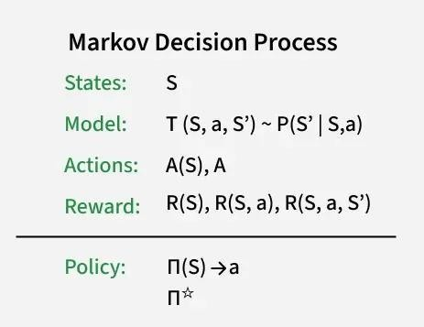
- States (S): A state is a situation or condition the agent can be in. For example, A position on a grid like being at cell (1,1).
- Actions (A): An action is something the agent can do. For example, Move UP, DOWN, LEFT or RIGHT. Each state can have one or more possible actions.
- Transition Model (T): The model tells us what happens when an action is taken in a state. It’s like asking: —If I move RIGHT from here, where will I land?‖ Sometimes the outcome isn’t always the same that’s uncertainty. For example:
- 80% chance of moving in the intended direction
- 10% chance of slipping to the left
- 10% chance of slipping to the right
This randomness is called a stochastic transition.
- Reward (R): A reward is a number given to the agent after it takes an action. If the reward is positive, it means the result of the action was good. If the reward is negative it means the outcome was bad or there was a penalty help the agent learn what’s good or bad. Examples:
● +1 for reaching the goal
- -1 for stepping into fire
- -0.1 for each step to encourage fewer moves

- Policy (π): A policy is the agent’s plan. It tells the agent: —If you are in this state, take this action.‖ The goal is to find the best policy that helps the agent earn the highest total reward over time.

Applications
Markov Decision Processes are useful in many real-life situations where decisions must be made step-by-step under uncertainty. Here are some applications:
- Robots and Machines: Robots use MDPs to decide how to move safely and efficiently in places like factories or warehouses and avoid obstacles.
- Game Strategy: In board games or video games MDPs help characters to choose the best moves to win or complete tasks even when outcomes are not certain.
- Healthcare: Doctors can use it to plan treatments for patients, choosing actions that improve health while considering uncertain effects.
- Traffic and Navigation: Self-driving cars or delivery vehicles use it to find safe routes and avoid accidents on unpredictable roads.
- Inventory Management: Stores and warehouses use MDPs to decide when to order more stock so they don’t run out or keep too much even when demand changes.

The Information Sources in Tagging
Information sources in NLP tagging (like Part-of-Speech tagging or Named Entity Recognition) come from linguistic rules, large annotated text corpora (training data), and statistical models (like HMMs, CRFs, neural networks) that learn from this data to assign grammatical or semantic labels (e.g., noun, verb, person, location) to words based on their form and context, resolving ambiguity and enabling deeper text understanding.

Key Information Sources
- Lexical & Linguistic Knowledge (Rule-Based):
  - Dictionaries & Lexicons: Provide base information about word forms (e.g., "run" can be a verb).
  - Hand-Crafted Rules: Manually created linguistic rules capture grammar and context (e.g., a word after "the" is likely a noun or adjective).

78

- Annotated Data (Training Corpora):
  - Large Text Datasets: Vast collections of text (books, web pages, social media) are manually tagged by humans.
  - Training Examples (Word-Tag Pairs): These annotated examples (e.g., "The/DT quick/JJ brown/JJ fox/NN") teach models patterns of how words are tagged in different contexts.
- Statistical Models & Algorithms:
  - Probability & Likelihood: Models learn the probability of a word getting a certain tag given its neighbors (e.g., P(NN|JJ, DT)).
  - Machine Learning: Algorithms (like HMMs, CRFs, deep learning models) analyze features (word shape, context, prefixes/suffixes) from the training data to predict tags for new text.

How They Work Together (Example: POS Tagging)
- A model trained on an annotated corpus learns that "bank" is usually a Noun (NN) in "river bank" but a Verb (VB) in "bank closes".
- When given a new sentence, it uses these learned probabilities and rules to assign the most likely tag sequence, resolving ambiguity (e.g., distinguishing "watch" as a noun vs. a verb).

The Information Sources in Tagging: Markov model taggers
Markov model taggers, especially Hidden Markov Models (HMMs), use words as observations and Parts-of-Speech (POS) tags as hidden states, leveraging transition probabilities (tag to tag, like "Noun" to "Verb") and emission probabilities (tag to word, like "Noun" to "cat") to find the most likely tag sequence for a sentence, acting as powerful statistical tools for automated linguistic tagging. These models combine simple word lookup with complex contextual info, relying on a Markov assumption (next state depends only on the current) for efficiency, making them fundamental in NLP.

Why Markov Models?
- Handles Ambiguity: Words can be multiple POS (e.g., "back" as noun, verb, adj). HMMs use context (surrounding words/tags) to decide the best fit.
- Statistical Power: They go beyond simple dictionaries by modeling grammatical structures and common word sequences.

- Foundation for Advanced NLP: HMMs are a core technique, often combined with other sources (like morphology, syntax) via methods like Maximum Entropy (ME) for better results.

The Viterbi Algorithm
The Viterbi algorithm is a fundamental dynamic programming technique widely used in the context of Hidden Markov Models (HMMs) to uncover the most likely sequence of hidden states given a sequence of observed events.
Given a series of observed events, the Viterbi algorithm determines the most likely order of hidden states in an HMM. Andrew Viterbi, who first proposed the algorithm in 1967, is honored by the algorithm's name. The most likely sequence of states is computed efficiently by the Viterbi method, which divides the issue into smaller subproblems and solves them recursively.
The Viterbi algorithm operates by iteratively computing the highest probability paths to each state at each time step, storing these probabilities, and backtracking to determine the most probable sequence of hidden states. This method ensures an efficient and accurate decoding of hidden state sequences, making it indispensable for applications that require precise sequence analysis and pattern recognition.

Applications of Viterbi in HMM
The Viterbi algorithm is widely used in various applications:
- Speech Recognition: The Viterbi algorithm in speech recognition converts spoken words into text by determining the most likely word or phoneme sequence that corresponds to the detected acoustic signals. HMMs simulate the speech process by using observations to represent acoustic features and hidden states to represent phonemes.
- Bioinformatics: The Viterbi algorithm is used in bioinformatics to align DNA sequences, predict protein structures, and locate gene sequences. Biological sequences can be modeled using HMMs, where observations correspond to sequences of nucleotides or amino acids, and hidden states represent biological functions.
- Natural Language Processing: In NLP, the Viterbi algorithm is used for tasks such as part-of-speech tagging, named entity recognition, and machine translation. HMMs can model linguistic sequences, with hidden states representing grammatical categories and observations representing words.

Error Correction: In digital communications, the Viterbi algorithm is used for error correction to decode transmitted messages that may have been corrupted by noise. HMMs can model the transmission process, with hidden states representing the transmitted symbols and observations representing the received symbols.

Applying HMMs to POS tagging
A Hidden Markov Model is a statistical model used to understand systems where the actual states are not directly visible, but we can see outcomes that depend on those hidden states. In simple terms, HMM helps us figure out what is going on behind the scenes based on what we observe.
Example: Suppose you are trying to guess the weather each day, but you can't look outside. Instead, you watch what people do. If someone is walking, shopping, or cleaning, these actions give you clues about what the weather might be like.
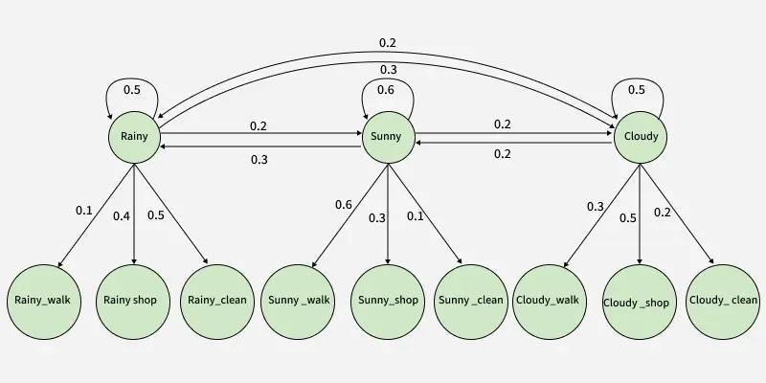
This HMM model helps determine the most likely sequence of hidden weather states based on a sequence of observed activities.

Initial Probabilities (Self-Loops)
These represent the probability of the system remaining in the same weather state:
  - Probability of staying in Rainy: 0.5
  - Probability of staying in Sunny: 0.6
  - Probability of staying in Cloudy: 0.5
81

Transition Probabilities (Weather to Weather)
These indicate the likelihood of transitioning from one weather state to another:
  - From Rainy to Sunny: 0.2
  - From Rainy to Cloudy: 0.3
  - From Sunny to Rainy: 0.3
  - From Sunny to Cloudy: 0.2
  - From Cloudy to Rainy: 0.2
  - From Cloudy to Sunny: 0.2

Emission Probabilities (Weather to Activities)
These describe the probability of performing an activity given a specific weather condition:

When the weather is Rainy:
  - Probability of going for a walk: 0.1
  - Probability of going shopping: 0.4
  - Probability of cleaning: 0.5

When the weather is Sunny:
  - Probability of going for a walk: 0.6
  - Probability of going shopping: 0.3
  - Probability of cleaning: 0.1

When the weather is Cloudy:
  - Probability of going for a walk: 0.3
  - Probability of going shopping: 0.5
  - Probability of cleaning: 0.2

Components associated with Hidden Markov Models
Hidden Markov Models, or HMMs, are built around a few key ideas that help describe systems where we can observe some things, but not everything directly.
  - States: These are the underlying conditions or steps in a process that we can’t directly see. For example, in applications like speech recognition, the hidden

82

states could represent sounds or words that are being spoken, even though we don’t hear them in isolated form.
  - Observations: These are the actual signals or data points we can detect. Using the same example of speech recognition, the observations would be features of the audio, such as frequency patterns or sound waves, that we can measure from a recording.
  - Transition Probabilities: HMMs include a set of probabilities that show how likely it is to move from one hidden state to another. These are usually arranged in a matrix and help the model understand the usual flow or sequence between states.
  - Emission Probabilities: Each hidden state has its own set of probabilities for producing different observations. This tells the model how likely it is to see a certain observation when the system is in a specific state.
  - Initial State Probabilities: This part of the model shows how likely it is for the system to start in a particular state before any observations are made.

Challenges in POS Tagging with HMM
  - Unknown Words (Out-of-Vocabulary Problem): HMMs rely on training data to learn which words belong to which tags. If a word appears in a new sentence that was never seen during training, the model struggles to assign a tag because it has no emission probability for that word. This is especially common with names, technical terms, or misspelled words.
  - Data Sparsity: For rare word-tag combinations or tag transitions, the model may not have enough training examples to calculate accurate probabilities. This can lead to zero probabilities or incorrect tagging, especially with small datasets.
  - Context Limitation: HMMs only look at the previous tag (first-order Markov assumption). This means the model can’t fully understand longer-range dependencies in language, like a word being influenced by tags several steps before.
  - Ambiguity in Words: Many words can have multiple valid tags depending on context. For example, the word —book‖ can be a noun or a verb. HMMs might make the wrong choice if context isn’t strong or the probabilities are too close.

  - Independence Assumption: HMMs assume that the current word depends only on its tag, not on neighboring words. In reality, word meanings often rely on the surrounding context, which HMMs ignore.

Applications of Tagging
Tagging: The process of assigning a specific part-of-speech label to each word in a sentence.
Tagging applications organize digital content (images, web pages, data) for better search/filtering, manage physical assets (inventory, tools) for tracking, enhance web analytics (user behavior), secure IT systems (grouping apps), and improve user experience (e.g., social media photo organization) by adding metadata for context and discoverability across diverse fields like e-commerce, cloud management, and natural language processing (NLP).

Digital Content & Data Management
    - Website Content: Categorizing blog posts, products, or media for easier navigation and SEO.
    - E-commerce: Tagging products (e.g., "loafer") to match diverse customer search queries.
    - Image & Video: Organizing personal or professional photo/video libraries for quick searching.
    - Data Analytics: Using tags (like Google Analytics tags) to track user interactions and site performance.

IT & Cloud Infrastructure
    - Cloud Resources (AWS/Azure): Grouping resources (servers, databases) by environment (dev, prod), owner, or cost center for management and billing.
    - Application Security: Grouping applications by vulnerability, region, or exposure level for risk management.
    - System Performance: Tagging processes or threads for specific Workload Management (WLM) rules in operating systems.

Physical Asset & Inventory Tracking
    - Equipment Tagging: Using QR codes or RFID tags on tools, machinery, or IT assets for inventory, maintenance, and loss prevention.

    - Inventory Management: RFID tags speed up retail inventory counting and tracking items through supply chains.

User Experience & Social Media
    - Social Media: Tagging people in photos or adding relevant hashtags to posts for visibility and connection.
    - Personal Use: Organizing personal digital files, emails, or notes for quick retrieval.

Natural Language Processing (NLP)
    - Part-of-Speech (POS) Tagging: Identifying words as nouns, verbs, adjectives, etc., to simplify text and improve search.
    - Named Entity Recognition (NER): Identifying names, places, and organizations in text.

ies.
This example shows a Hidden Markov Model where the hidden states are weather conditions (Rainy, Cloudy, Sunny) and the observations are emotions (Happy, Neutral, Sad).
    - The green arrows represent transition probabilities, showing how likely the weather is to change from one state to another each day.
    - Red arrows represent emission probabilities, showing how likely each emotion is given the current weather.

    - Since we only observe the emotions and not the actual weather, the HMM helps infer the most probable hidden weather pattern behind those observations.

Assumptions of HMM
- Hidden States
  - The actual state of the system is not visible.
  - Example: Weather (Sunny/Rainy) is hidden.
- Observations
  - We only see the outcomes produced by the hidden states.
  - Example: Friend’s mood (Happy/Sad) is observed.
- Markov Property
The model assumes the future state depends only on the current state not on the entire history.

  - Components of a Hidden Markov Model (HMM) A Hidden Markov Model is defined by λ=(A,B,π)λ=(A,B,π)
where
  - AA (Transition Matrix): Probability of moving from one hidden state to another.
  - BB (Emission Matrix): Probability of observing a symbol given a hidden state.
  - ππ (Initial State Distribution): Probability of starting in each hidden state.
- Hidden States (N): These are the internal states of the system, which are not directly observable.
- Observations (M): These are the visible outputs generated by the hidden states.
- Initial State Distribution (ππ): Represents the probability of starting in each hidden state.
- Transition Probabilities (A): Defines the probability of moving from one hidden state to another.
- Emission Probabilities (B): Defines the probability of producing a particular observed output from a given hidden state.

Three Fundamental Problems in Hidden Markov Models (HMMs)

Hidden Markov Models solve three core problems related to sequences of observations generated by hidden states.

Evaluation Problem (Forward Algorithm)
Problem: How to compute the probability of an observation sequence? Mathematically, given an observation sequence: O={o1,o2,…,oT}O={o1 ,o2 ,…,oT }
and a model:
λ=(A,B,π)λ=(A,B,π)
we compute:
P(O∣λ)=∑all state sequences QP(O,Q∣λ)P(O∣λ)=∑all state sequences Q P(O,Q∣λ)
Because summing over all possible state sequences is computationally expensive, the Forward Algorithm efficiently computes this probability using dynamic programming with the forward variable:
αt(j)=P(o1,o2,…,ot,qt=j∣λ)αt (j)=P(o1 ,o2 ,…,ot ,qt =j∣λ)

Decoding Problem (Viterbi Algorithm)
Problem: How to find the most likely hidden state sequence that explains the observations?
Mathematically, it finds:
Q∗=arg⁡max⁡QP(Q∣O,λ)Q∗=argmaxQ P(Q∣O,λ)
The Viterbi Algorithm efficiently computes this using dynamic programming by keeping track of the maximum probability path to each state at each time step.
- Learning Problem (Baum–Welch Algorithm / EM) Problem: How to train the HMM to fit the observed data?
Here, the goal is to estimate the model parameters that maximize the likelihood of the observation sequence:
λnew=arg⁡max⁡λP(O∣λ)λnew =argmaxλ P(O∣λ)
The Baum Welch Algorithm (a type of Expectation-Maximization) iteratively updates estimates of AA, BB and ππ using the state occupancy probabilities and transition probabilities computed from the observation sequence.

HMM Algorithm
Step 1 Define State and Observation Space
  - Hidden States: Possible internal states the system can be in.
  - Observations: Visible outputs generated by hidden states.

Step 2 Define Initial State Distribution (ππ): Set probabilities of starting in each hidden state.
Step 3 Define Transition Matrix (A): Set probabilities for moving from one hidden state to another.
Step 4 Define Emission Matrix (B): Set probabilities for each observation being emitted by a hidden state.
Step 5 Train Model: Estimate model parameters using:
  - Baum Welch Algorithm: Trains HMM by estimating A, B,ππ.
  - Forward Backward Algorithm: Computes hidden state probabilities efficiently. Step 6 Decode Hidden States: Determine the most likely hidden state sequence using the Viterbi algorithm.
Step 7 Evaluate Model Performance: Measure model accuracy using metrics like Accuracy, Precision and Recall.

Step-By-Step Implementation
Step 1: Import Libraries
Step 2: Define Markov Chain States & Transition Matrix Step 3: Simulate Markov Chain Sequence
Step 4: Define HMM Parameters
Step 5: Generate Observations from HMM Step 6: Decode Hidden States Using Viterbi Step 7: Visualize HMM Transition Matrix

Applications
  - Bioinformatics: Models DNA/protein sequences for gene identification and protein classification.
  - Finance: Capture hidden market states to predict trends and detect bullish/bearish periods.
  - NLP: Perform POS tagging, NER and early machine translation using sequential text modeling.
  - IoT and Cybersecurity: Detect anomalous event sequences in sensors or logs.
  - Weather Forecasting: Predict future weather patterns from historical data sequences.

88

  - Activity Recognition in Wearables: Classify activities like walking, running or sleeping using sensor

Advantages
  - Easy to Interpret: Clear probabilistic structure of hidden states and observations.
  - Works Well on Small Datasets: Requires less data compared to deep learning models.
  - Fast Inference: Efficient algorithms like Forward and Viterbi enable quick computation.
  - Strong for Anomaly Detection: Can detect unusual sequences effectively.
  - Mathematically Elegant: Solid foundation in probability and statistics.

Limitations
  - Markov Assumption: Only considers the previous state, limiting long-range dependencies.
  - Discrete Hidden States: Struggles with continuous or non-categorical hidden states.
  - Difficulty with Complex Sequences: Less effective than RNNs or LSTMs on complex sequences.
  - Limited Long-Term Memory: Cannot remember distant past events effectively.
  - Less Accurate for High-Dimensional Inputs: Performance drops with high-dimensional data.

Markov Property
A process has the Markov property if the probability of moving to a future state depends only on the present state and not on the past.

Parameters to Estimate
A standard HMM is defined by a set of parameters, often denoted collectively as 𝜆, which includes:
- Initial State Distribution (𝜋): The probabilities of the hidden process starting in each possible state.

89

- Transition Probability Matrix (A): The probabilities of moving from one hidden state to another over time.
- Emission (or Observation) Parameters (Θor B): The parameters of the probability distributions that determine the likelihood of observing a particular output given a specific hidden state (e.g., mean and standard deviation for Gaussian emissions, or a discrete probability matrix for categorical observations).

Common Estimation Algorithms
  - Baum-Welch Algorithm: This is the most common and widely used method, which is a special case of the Expectation-Maximization (EM) algorithm. It iteratively re-estimates the parameters to maximize the likelihood of the observed sequence(s). It is generally robust to poor initial values but can be slow to converge.
  - Direct Numerical Maximization (DNM): This approach directly maximizes the (log-)likelihood function using general-purpose optimization algorithms (such as quasi-Newton methods like L-BFGS-B). DNM can be faster than the Baum-Welch algorithm in certain scenarios but may be more sensitive to initial parameter values.
  - Viterbi Training: This is a simpler, heuristic approach that uses the Viterbi algorithm in each iteration to find the single most likely sequence of hidden states, and then estimates parameters based on the frequency counts of these paths. It is generally faster than Baum-Welch but less accurate.
  - Bayesian Methods (MCMC/Gibbs Sampling): These methods, such as Markov Chain Monte Carlo (MCMC) sampling or Gibbs sampling, are used for more sophisticated Bayesian inference, which can offer better accuracy and stability for time-series prediction than single maximum likelihood estimates.
  - Sequential Monte Carlo (SMC) / Particle Filters: These methods are used when the model likelihood is intractable or the state space is continuous.

Variants
Markov model variants extend the basic concept (memoryless transitions) to handle different complexities like hidden states (HMM), control (MDP), time (Continuous-Time/Semi-Markov), and structure (MRF, Hierarchical), enabling
90

modeling from simple sequences (Markov Chains) to complex decision-making (POMDP) and spatial data (Markov Random Fields), crucial in genomics, finance, and AI.

Advanced Variants
  - Markov Random Field (MRF): Models relationships between variables in a graph, capturing spatial dependencies (e.g., image processing).
  - Hierarchical Markov Models: Models systems with multiple levels of states, capturing both short-term and long-term behaviors.
  - Semi-Markov Models: Generalize CTMCs by allowing the time spent in a state to follow any distribution, not just exponential.
  - Interpolated Markov Models (IMM): Used in genomics, combine models of different orders (lengths of history) to improve accuracy.

Multiple Input Observations
Markov model context, handling "multiple input observations" typically refers to two scenarios: either processing a single sequence of observations where each observation is a multi-dimensional vector, or processing multiple independent observation sequences.
Markov Decision Process (MDP) is a way to describe how a decision-making agent like a robot or game character moves through different situations while trying to achieve a goal. MDPs rely on variables such as the environment, agent’s actions and rewards to decide the system’s next optimal action. It helps us answer questions like:
  - What actions should the agent take?
  - What happens after an action?
  - Is the result good or bad?
In artificial intelligence Markov Decision Processes (MDPs) are used to model situations where decisions are made one after another and the results of actions are uncertain. They help in designing smart machines or agents that need to work in environments where each action might led to different outcomes.

91

- States (S): A state is a situation or condition the agent can be in. For example, A position on a grid like being at cell (1,1).
- Actions (A): An action is something the agent can do. For example, Move UP, DOWN, LEFT or RIGHT. Each state can have one or more possible actions.
- Transition Model (T): The model tells us what happens when an action is taken in a state. It’s like asking: —If I move RIGHT from here, where will I land?‖ Sometimes the outcome isn’t always the same that’s uncertainty. For example:
  - 80% chance of moving in the intended direction
  - 10% chance of slipping to the left
  - 10% chance of slipping to the right
This randomness is called a stochastic transition.
- Reward (R): A reward is a number given to the agent after it takes an action. If the reward is positive, it means the result of the action was good. If the reward is negative it means the outcome was bad or there was a penalty help the agent learn what’s good or bad. Examples:
● +1 for reaching the goal
  - -1 for stepping into fire
  - -0.1 for each step to encourage fewer moves

92

- Policy (π): A policy is the agent’s plan. It tells the agent: —If you are in this state, take this action.‖ The goal is to find the best policy that helps the agent earn the highest total reward over time.

Applications
Markov Decision Processes are useful in many real-life situations where decisions must be made step-by-step under uncertainty. Here are some applications:
  - Robots and Machines: Robots use MDPs to decide how to move safely and efficiently in places like factories or warehouses and avoid obstacles.
  - Game Strategy: In board games or video games MDPs help characters to choose the best moves to win or complete tasks even when outcomes are not certain.
  - Healthcare: Doctors can use it to plan treatments for patients, choosing actions that improve health while considering uncertain effects.
  - Traffic and Navigation: Self-driving cars or delivery vehicles use it to find safe routes and avoid accidents on unpredictable roads.
  - Inventory Management: Stores and warehouses use MDPs to decide when to order more stock so they don’t run out or keep too much even when demand changes.

The Information Sources in Tagging
Information sources in NLP tagging (like Part-of-Speech tagging or Named Entity Recognition) come from linguistic rules, large annotated text corpora (training data), and statistical models (like HMMs, CRFs, neural networks) that learn from this data to assign grammatical or semantic labels (e.g., noun, verb, person, location) to words based on their form and context, resolving ambiguity and enabling deeper text understanding.

Key Information Sources
- Lexical & Linguistic Knowledge (Rule-Based):
- Dictionaries & Lexicons: Provide base information about word forms (e.g., "run" can be a verb).
- Hand-Crafted Rules: Manually created linguistic rules capture grammar and context (e.g., a word after "the" is likely a noun or adjective).
93

- Annotated Data (Training Corpora):
- Large Text Datasets: Vast collections of text (books, web pages, social media) are manually tagged by humans.
- Training Examples (Word-Tag Pairs): These annotated examples (e.g., "The/DT quick/JJ brown/JJ fox/NN") teach models patterns of how words are tagged in different contexts.
- Statistical Models & Algorithms:
- Probability & Likelihood: Models learn the probability of a word getting a certain tag given its neighbors (e.g., P(NN|JJ, DT)).
- Machine Learning: Algorithms (like HMMs, CRFs, deep learning models) analyze features (word shape, context, prefixes/suffixes) from the training data to predict tags for new text.

How They Work Together (Example: POS Tagging)
- A model trained on an annotated corpus learns that "bank" is usually a Noun (NN) in "river bank" but a Verb (VB) in "bank closes".
- When given a new sentence, it uses these learned probabilities and rules to assign the most likely tag sequence, resolving ambiguity (e.g., distinguishing "watch" as a noun vs. a verb).

The Information Sources in Tagging: Markov model taggers
Markov model taggers, especially Hidden Markov Models (HMMs), use words as observations and Parts-of-Speech (POS) tags as hidden states, leveraging transition probabilities (tag to tag, like "Noun" to "Verb") and emission probabilities (tag to word, like "Noun" to "cat") to find the most likely tag sequence for a sentence, acting as powerful statistical tools for automated linguistic tagging. These models combine simple word lookup with complex contextual info, relying on a Markov assumption (next state depends only on the current) for efficiency, making them fundamental in NLP.

Why Markov Models?
- Handles Ambiguity: Words can be multiple POS (e.g., "back" as noun, verb, adj). HMMs use context (surrounding words/tags) to decide the best fit.
- Statistical Power: They go beyond simple dictionaries by modeling grammatical structures and common word sequences.

94

- Foundation for Advanced NLP: HMMs are a core technique, often combined with other sources (like morphology, syntax) via methods like Maximum Entropy (ME) for better results.

The Viterbi Algorithm
The Viterbi algorithm is a fundamental dynamic programming technique widely used in the context of Hidden Markov Models (HMMs) to uncover the most likely sequence of hidden states given a sequence of observed events.
Given a series of observed events, the Viterbi algorithm determines the most likely order of hidden states in an HMM. Andrew Viterbi, who first proposed the algorithm in 1967, is honored by the algorithm's name. The most likely sequence of states is computed efficiently by the Viterbi method, which divides the issue into smaller subproblems and solves them recursively.
The Viterbi algorithm operates by iteratively computing the highest probability paths to each state at each time step, storing these probabilities, and backtracking to determine the most probable sequence of hidden states. This method ensures an efficient and accurate decoding of hidden state sequences, making it indispensable for applications that require precise sequence analysis and pattern recognition.

Applications of Viterbi in HMM
The Viterbi algorithm is widely used in various applications:
- Speech Recognition: The Viterbi algorithm in speech recognition converts spoken words into text by determining the most likely word or phoneme sequence that corresponds to the detected acoustic signals. HMMs simulate the speech process by using observations to represent acoustic features and hidden states to represent phonemes.
- Bioinformatics: The Viterbi algorithm is used in bioinformatics to align DNA sequences, predict protein structures, and locate gene sequences. Biological sequences can be modeled using HMMs, where observations correspond to sequences of nucleotides or amino acids, and hidden states represent biological functions.
- Natural Language Processing: In NLP, the Viterbi algorithm is used for tasks such as part-of-speech tagging, named entity recognition, and machine translation. HMMs can model linguistic sequences, with hidden states representing grammatical categories and observations representing words.

- Error Correction: In digital communications, the Viterbi algorithm is used for error correction to decode transmitted messages that may have been corrupted by noise. HMMs can model the transmission process, with hidden states representing the transmitted symbols and observations representing the received symbols.

Applying HMMs to POS tagging
A Hidden Markov Model is a statistical model used to understand systems where the actual states are not directly visible, but we can see outcomes that depend on those hidden states. In simple terms, HMM helps us figure out what is going on behind the scenes based on what we observe.
Example: Suppose you are trying to guess the weather each day, but you can't look outside. Instead, you watch what people do. If someone is walking, shopping, or cleaning, these actions give you clues about what the weather might be like.
This HMM model helps determine the most likely sequence of hidden weather states based on a sequence of observed activities.

Initial Probabilities (Self-Loops)
These represent the probability of the system remaining in the same weather state:
- Probability of staying in Rainy: 0.5
- Probability of staying in Sunny: 0.6
- Probability of staying in Cloudy: 0.5

Transition Probabilities (Weather to Weather)
These indicate the likelihood of transitioning from one weather state to another:
- From Rainy to Sunny: 0.2
- From Rainy to Cloudy: 0.3
- From Sunny to Rainy: 0.3
- From Sunny to Cloudy: 0.2
- From Cloudy to Rainy: 0.2
- From Cloudy to Sunny: 0.2

Emission Probabilities (Weather to Activities)
These describe the probability of performing an activity given a specific weather condition:

When the weather is Rainy:
- Probability of going for a walk: 0.1
- Probability of going shopping: 0.4
- Probability of cleaning: 0.5

When the weather is Sunny:
- Probability of going for a walk: 0.6
- Probability of going shopping: 0.3
- Probability of cleaning: 0.1

When the weather is Cloudy:
- Probability of going for a walk: 0.3
- Probability of going shopping: 0.5
- Probability of cleaning: 0.2

Components associated with Hidden Markov Models
Hidden Markov Models, or HMMs, are built around a few key ideas that help describe systems where we can observe some things, but not everything directly.
- States: These are the underlying conditions or steps in a process that we can’t directly see. For example, in applications like speech recognition, the hidden

states could represent sounds or words that are being spoken, even though we don’t hear them in isolated form.
- Observations: These are the actual signals or data points we can detect. Using the same example of speech recognition, the observations would be features of the audio, such as frequency patterns or sound waves, that we can measure from a recording.
- Transition Probabilities: HMMs include a set of probabilities that show how likely it is to move from one hidden state to another. These are usually arranged in a matrix and help the model understand the usual flow or sequence between states.
- Emission Probabilities: Each hidden state has its own set of probabilities for producing different observations. This tells the model how likely it is to see a certain observation when the system is in a specific state.
- Initial State Probabilities: This part of the model shows how likely it is for the system to start in a particular state before any observations are made.

Challenges in POS Tagging with HMM
- Unknown Words (Out-of-Vocabulary Problem): HMMs rely on training data to learn which words belong to which tags. If a word appears in a new sentence that was never seen during training, the model struggles to assign a tag because it has no emission probability for that word. This is especially common with names, technical terms, or misspelled words.
- Data Sparsity: For rare word-tag combinations or tag transitions, the model may not have enough training examples to calculate accurate probabilities. This can lead to zero probabilities or incorrect tagging, especially with small datasets.
- Context Limitation: HMMs only look at the previous tag (first-order Markov assumption). This means the model can’t fully understand longer-range dependencies in language, like a word being influenced by tags several steps before.
- Ambiguity in Words: Many words can have multiple valid tags depending on context. For example, the word —book‖ can be a noun or a verb. HMMs might make the wrong choice if context isn’t strong or the probabilities are too close.

- Independence Assumption: HMMs assume that the current word depends only on its tag, not on neighboring words. In reality, word meanings often rely on the surrounding context, which HMMs ignore.

Applications of Tagging
Tagging: The process of assigning a specific part-of-speech label to each word in a sentence.
Tagging applications organize digital content (images, web pages, data) for better search/filtering, manage physical assets (inventory, tools) for tracking, enhance web analytics (user behavior), secure IT systems (grouping apps), and improve user experience (e.g., social media photo organization) by adding metadata for context and discoverability across diverse fields like e-commerce, cloud management, and natural language processing (NLP).

Digital Content & Data Management
  - Website Content: Categorizing blog posts, products, or media for easier navigation and SEO.
  - E-commerce: Tagging products (e.g., "loafer") to match diverse customer search queries.
  - Image & Video: Organizing personal or professional photo/video libraries for quick searching.
  - Data Analytics: Using tags (like Google Analytics tags) to track user interactions and site performance.

IT & Cloud Infrastructure
  - Cloud Resources (AWS/Azure): Grouping resources (servers, databases) by environment (dev, prod), owner, or cost center for management and billing.
  - Application Security: Grouping applications by vulnerability, region, or exposure level for risk management.
  - System Performance: Tagging processes or threads for specific Workload Management (WLM) rules in operating systems.

Physical Asset & Inventory Tracking
  - Equipment Tagging: Using QR codes or RFID tags on tools, machinery, or IT assets for inventory, maintenance, and loss prevention.

  - Inventory Management: RFID tags speed up retail inventory counting and tracking items through supply chains.

User Experience & Social Media
  - Social Media: Tagging people in photos or adding relevant hashtags to posts for visibility and connection.
  - Personal Use: Organizing personal digital files, emails, or notes for quick retrieval.

Natural Language Processing (NLP)
  - Part-of-Speech (POS) Tagging: Identifying words as nouns, verbs, adjectives, etc., to simplify text and improve search.
  - Named Entity Recognition (NER): Identifying names, places, and organizations in text.

100

